**An android mobile application for a child’s personal and behavioural development**

**Craig A Corstorphine**

**TM470 Computing and IT project**

Table of Contents

The Problem 2

Benefits of solving the problem 4

Knowledge and impact problem 4

Project output and proposed solution 4

Description and scope of mobile app 5

The list of skills I need to develop 6

Stakeholders 7

Architecture 7

Account of related literature 8

Account of project work and its outcome 9

Overview 9

Current schedule and work completed 10

Project lifecycle choice 12

Requirements 13

Outline of the development process 14

Evidence, description, and explanation of the app 15

Java Classes implemented 24

Problems encountered 27

Testing the app 29

User Feedback 30

Final iteration work to do 31

Final iteration 31

Legal, Social, Ethical, and professional 32

Review of current stage of project work 32

Project Management 33

Assess risks to project completion 33

Review of personal development 35

Appendices 36

1 36

2 37

3 37

4 38

5 38

6 39

7 39

8 40

9 40

10 41

# The Problem

My daughter has always responded better to being rewarded for good behaviour than being punished for bad behaviour. It is very well documented that a reward system can have great benefits on child behaviour (CDC 2019). A document on the CDC website lists the benefits as improved behaviour, increased self-esteem, and an improved relationship with the child (CDC 2019).

Rewards can encourage good behaviour, increase self-esteem, and improve the relationship with the child. Although children can respond better to specific types of parenting, I am going to develop a mobile app to help compliment my parenting approach.

Rewards can encourage good behaviour, increase self-esteem, and improve the relationship with the child. Although children can respond better to specific types of parenting, the App going to be developed will compliment my parenting approach.

It can be hard to keep track of a child’s behaviour and development over the weeks and months, and an app can help track that. In the past I have used a paper chart and sticker system, but without a reminder or notification it was often forgotten about. There was also not easy to document past weeks and months that wouldn’t require a separate document. The paper chart would also become a mess if mistakes were made, and it was harder to amend. A plastic chart involves add and removing hundreds of stickers every week which over a long time can become costly. A mobile application made for my personal use will solve these issues as well as saving me a subscription fee to another app that does not serve my personal circumstances.

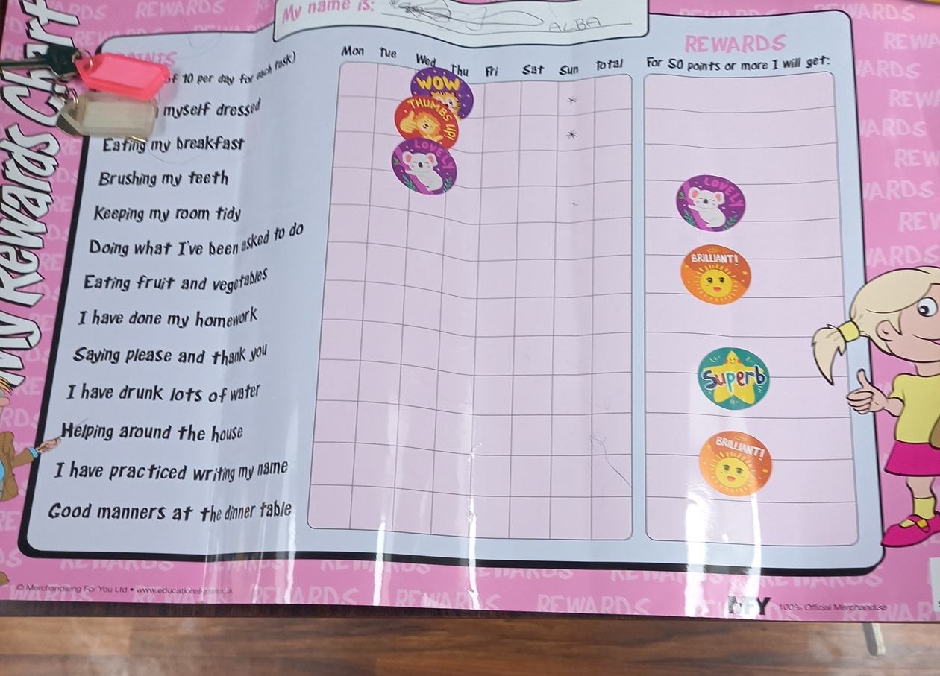

*(Above) The picture above is a sticker chart used by my family. After a week it takes considerable time to remove all the stickers*

Although this app is to be developed for the benefit of my own family, there is the potential for other parents to download and use the app. Now that Covid19 restrictions are easing It will be easier to test the App with other potential users/parents. I will consider other parents as stakeholders although some alterations may be made to the app before it is made available to the public if I chose to do this. This would include a more generic layout and look that is not so personal to my family. Other aspects to consider would be add more features and make the app more customisable for other users.

## Benefits of solving the problem

There are multiple benefits to solving this problem which include improved child behaviour and reduction of tantrums. This can be through the impact of rewarding good behaviour and making it a habit. A happier child is also likely as there will be a decrease in punishments that may affect self-esteem. The child can also become familiar with a delayed reward system as they earn points and rewards over the short to medium term periods. An example would be a certain reward after a day or week of satisfactory behaviour.

It may also benefit and help with educational development as rewards can be earned for schoolwork and/or grades. In a practical and logistical sense, money and time can be saved. There is no longer a need to buy stickers and new charts, as well as not having to buy or subscribe to another app.

## Knowledge and impact problem

My knowledge mostly comes from personal experience with my daughter, and a lot through trial and error. Like most parents we went through the process of reading the recommended books on toddler development. I know that a reward system works for my daughter as I’ve implemented one with sticker charts before. There is also a lot of research done on reward systems for children as well as Gamification. “Gamification is the application of game mechanisms in non-gaming environments (Kalpana Nand, Nilufar Baghaei, John Casey, Bashir Barmada, Farhad Mehdipour & Hai-Ning Liang, 2019)

Gamification is a method that can be successfully implement into the app.

Ganit Richter, Daphne Raban, Sheizaf Rafaeli (10,2015) Paper in Gamification talks about goal setting theory and the fact that short and intermediate goals tend to motivate and help participants achieve more. The paper goes on to say that specific goal setting that is sufficiently challenging and shows feedback of progress is likely to have beneficial results Ganit Richter, Daphne Raban, Sheizaf Rafaeli (10,2015)

As the app is being developed for personal use the impact will be minimal unless the decision to release it to the public is made. If this happens the impact of solving this problem will come mostly in the form of child behavioural development and convenience on a personal level. There will be no more need for sticker charts that become messy as well as saving money and paper as well as no subscriptions fees for other similar applications. There is also the benefit of having the calendar to look back on and check on development which can be helpful for finding triggers for poor behaviour if the user has documented it well enough. As stated earlier this app is for personal use, however with some modification it can be easily released on the Google Play Store for the wider public meaning the app would have a wider impact. This could mean that more parents can benefit from the app than just my family.

## Project output and proposed solution

The proposed solution is an android application to facilitate behavioural and learning development of a child. I have made some amendments to the scope of this project that will suit personal needs. The app will focus more on short term daily tasks and rewards as opposed to weekly or monthly ones. Long term goals don’t seem to work as efficiently with younger children, especially before school age. Again, as this app is firstly for personal use it will be configured to suit my situation. It will however be easily modified for public use. A future feature may be making the App customisable by the child’s age. The app it’s self will include a log/register function, Calendar to log progress, task list that is customizable, a maths quiz and a notification system. The specific description and scope are listed in the next section.

## Description and scope of mobile app

The app will be designed for parental use mainly but will feature aspects that the child can use. It will work by scheduling chores and tasks with a daily calendar system and points can be earned by completing tasks or quizzes.

* A mobile app to reward good behaviour through a kudos system (Reward points). Kudos can be earned through completing chores, tasks, and good behaviour.
* A login or register new user function to help prevent child access.
* I will implement a calendar system, so it is possible to track past present and future tasks, events, and rewards.
* Accumulation of kudos will translate into certain rewards that can be listed on the app. (Example, 5 kudos may earn extra TV or tablet time)
* Physical tasks that are completed outside of the app will require a password entered by an adult to add reward points(kudos).
* The higher number of Kudos, the better the reward. (Agreed by child and parent)
* Tasks on the app itself, like a Multiplication test can be completed by the child.
* Kudos will be reset daily, and new rewards and tasks can be entered into the app manually.
* Kudos can also be removed or edited.
* The difficulty of the Math test can be set
* The App will give a daily reminder in the form of a notification.
* The App will give a notification when certain milestones are reached (accumulation of kudos for a certain reward).
* The App should be designed in a simple but aesthetic manner that is intuitive to use.
* SQLite will be used for the database to store user details, tasks, and kudos
* The App is primarily for parental use.

Features that are out of scope

* Something that was considered was the use of firebase to store and authenticate user details. This is something that would be considered in the future that could if the application was to be expanded to a larger userbase.
* Animations could also be added to mark goals or tasks being completed, however I feel this is slightly out of my capabilities at this current time. I may be considered in a future version.
* Learning games. This would require quite a significant amount of time and skill to implement to a good standard

ICT aspects and resources

|  |  |
| --- | --- |
| Resource/ICT Aspect | Uses/Description |
| Android Studio | This is Android official IDE for mobile app development. It covers the front end and back of the mobile development. Android gives the developer a visual representation of the app through the layout activity that brings an ease to front end development that other technologies like Cordova lack |
| Java | Java is an Object-Oriented Programming language that can be used within android studio. This covers the functionality of the App and connects aspects of the front end (Buttons etc) together |
| XML | XML is a mark-up language used for the front-end design and development of the mobile application. Is used within android studio and can be autogenerated for some elements. For example, it is possible to drag and drop buttons onto the activity layout. |
| SQLite Database | SQLite provides the relation database functionality within the app. This will be essential for storing user details. |
| Gradle | Gradle comes installed within Android studio and is essential to its functionality. It facilitates the build process as well as testing and debugging. |
| Native Mobile Application Development (Android) | This is a combination of all the aspects above, bring them together into a functional app that serves a novel or important purpose. As it is Android only being used this is classed as native development. The benefits include better performance, security, and access to the platforms full set of features (ClearBridge Mobile no date) |
| Object Oriented Programming | This is essential as Java uses the classes system. This helps break code down into smaller more manageable sections. within Classes methods are used to break down the code further. |
| Version control (GitHub) | GitHub is a form of version control and allows developers to upload projects into repositories. This is a safe way to store the project. |

## The list of skills I need to develop

The following table is a list of skills I need to develop and learn for the project to be a successful one

|  |  |
| --- | --- |
| Mobile Application development using Android studio | This is critical to the project as it is where most of the development process will take place. |
| XML in relation to the visuals and the aesthetics of the application | I will need to learn how to implement XML for the UI and visuals of the app |
| SQLite for database storage | I will need to learn how to use SQLite to implement databases into the app for storage |
| UX Design principles | This is a skill I lack and will need to work on to improve on the user experience of the app |
| Software development skills | I have some skills already in software development, but as this is the biggest project I have developed, I will refine my knowledge. |
| project management skills | Project management skills is something I will develop and refine as the project progresses. |
| Time management | Time management is critical to the success of the project |
| Testing | I will need to research testing methods as I have very limited knowledge of testing. |
| Research skill | Research is a skill I will develop as the project progresses |
| interviewing skills | I will need to research interview techniques to decide on the best questions to ask when producing user tests and getting user feedback. |

## Stakeholders

* My wife, and myself will be the main users of the app
* My Daughter, as her personal development is what the app will be used for. She will also participate in the use of the app.
* Potentially other members of the family
* Family members and friends with children
* Potentially members of the public if I decide to release it on the app store.

## Architecture

The app will be built using Android studio for the Android platform, which will help me develop the front and back end of the application. I will be using java for the back end (ViewModel), XML (UI Controller) for the front and SQLite for the database. Below is a diagram of the components of the android platform architecture (Android platform documentation, figure 1, No date)

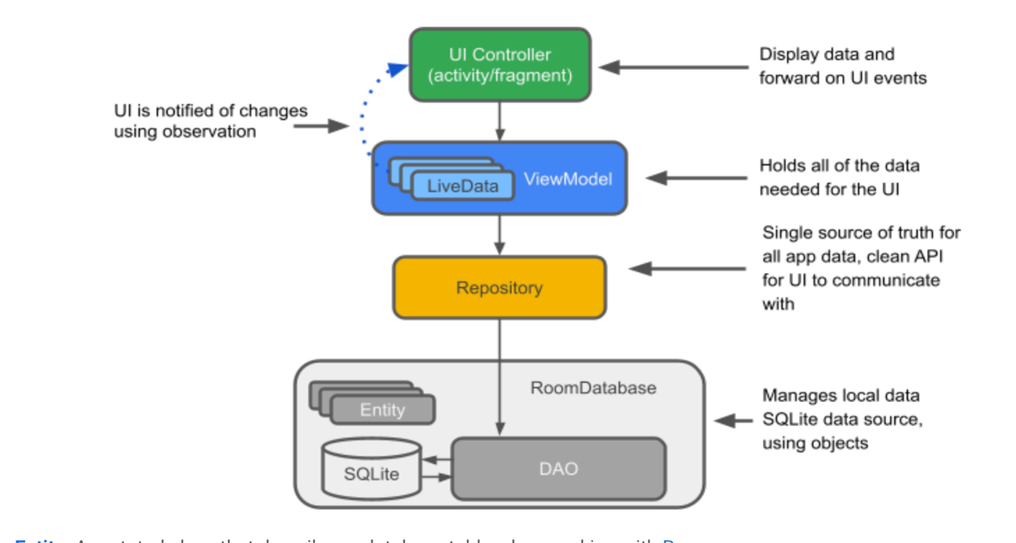

*(Android platform documentation, figure 1, No date)*

## Account of related literature

SQLite tutorial Anupam Chugh (07/2021)

One of the biggest challenges in building this App was implementing the database using SQLite. Without a tutorial this would have perhaps taken a considerable amount of time. After an extensive internet search, I discovered a tutorial that seemed to match my needs. Anupam Chugh(no date) This walked me through the use of SQLiteOpenHelper Class helping me understand how I can implement it into my App. It was very clear on how to create and insert data into tables. The author Anupam Chugh is a frequent contributor to the website journaldev.com. Although it can be difficult to decide whether a tutorial is credible his method has been successfully implemented with some changes and after testing appears to be functional.

Tim Buchalka’s Android Java Masterclass(online tutorial/no date

In terms of navigating and understanding how to use Android studio as well as initially setting up a project Tim Buchalka’s Android Java Masterclass(online tutorial/no date) has been a valuable resource. This has taught me the basic aspects of setting up a project and how deal with the often-fiddly constraint layout with XML. It was also very helpful in understand what the android manifest does and what to include. I have had problems with activity(Screens) not linking together, only to find out I had not included them in the manifest. Although I did not complete the whole tutorial as it is vast, I did complete enough to become confident using Android Studio. The instructor Tim Buchalka has over 35+ years’ experience and is highly rated on many educational sites included Udemy.com and boasts over 500,000 students world-wide. He is considered a very reliable source of information and education in programming

Register/login tutorial (razormist  4, 2021

After trying unsuccessfully in getting the login and register activity to work I again looked for a tutorial. To help me implement this in my project I searched for up-to-date tutorials. It took me some time to find an up to date one. Android studio is constantly changing and updating so many old tutorials from 4 or 5 years ago are very outdated and don’t fully work. I eventually found (razormist  4, 2021) and it helped guide me through the process, although it was still slightly challenging putting it into my App and the code needed to be adapted to suit it. Little is known about the author unfortunately, however the tutorial is very recent and having tested it there seems to be no issues with functionality.

Clean Code(Robert C. Martin(2009)

As the project was developing, the code tended to get messy as naming of the variables were not carefully chosen. Making the decision to go back and look at Clean Code(Robert C. Martin(2009) and rename certain classes and variables that did not make any sense has help. Lucky in android studio there is a refactor setting in the menu that allows you to rename a variable or class once and it will change it in every part of the code or file that it features, saving the time of going through all the code again. An example of poor variable names used were “btn1” instead of something more descriptive such has TaskActivtyButton. Robert Martin is a software engineer and author. He is considered a very reliable source within software design principles.

shared pref tutorial, Anupam Chugh(No date)

As in the SQLite tutorial Anupam Chugh’s tutorial has been very helpful in using and implementing shared preferences to store small amounts of data. In this case it was to store the kudos which is a single integer. The author Anupam Chugh is a frequent contributor to the website journaldev.com. Although it can be difficult to decide whether a tutorial is credible his method has been successfully implemented with some changes and after testing it appears to be functional.

Save data using SQLite(No date)

SQLite is necessary for my application to store data such as user details and the task lists. To try to fully understand SQLite I made use of the official android training. This helped to break down and understand the steps in using the SQL helper and to implement it into the application.

As this is official android documentation it can be considered the most reliable source on the subject, however official documentation is not always the easiest to understand so a mixture of this and other sources have been used.

Studying Gamification 2.4.3 Goal Setting Theory, Ganit Richter, Daphne Raban, Sheizaf Rafaeli (10,2015)

This resource gives a deeper look into goal setting in the short- and medium-term time frames. It emphasises the benefits of keeping goals over shorter periods as it has a greater motivational effect on the participant. This has been valuable information as it has helped me make decisions on how to set goals and the periods they should last for

# Account of project work and its outcome

## Overview

The Project has proven to be challenging with many new concepts such as SQLite and creating a calendar. Progress however is going well, and the second iteration of the project has been completed. The first Iteration consisted of creating the login activity, register activity, and the task list activity. In the second activity amendments were made and the Math quiz and calendar were added.

## Current schedule and work completed

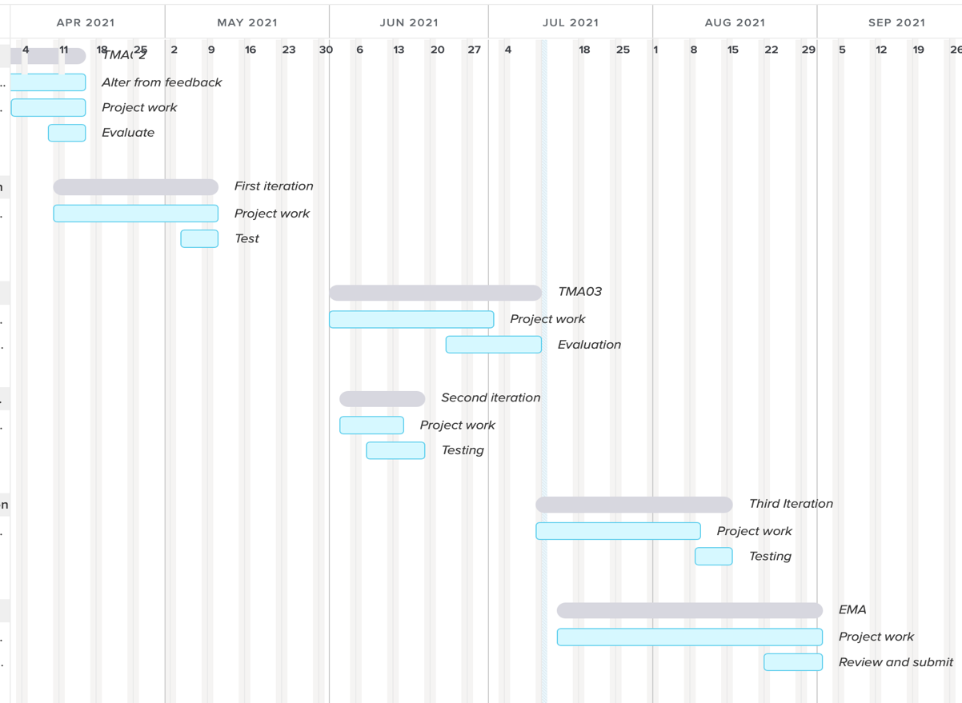

*(Above)Gantt chart(designed by team Gantt(no date)*

Above shows the current changes to my schedule. The chart shows the second iteration is far shorter than planned and only lasted 15 days. This was due to my daughter nursery being closed due to Covid. I had to work intensely for the 15 days to catch up with project work including testing. I have documented more details in the review section.

**WBS**

|  |  |  |  |  |  |
| --- | --- | --- | --- | --- | --- |
| **Start date** | **End Date** |  | **Name & Description** | **Status** | **Comments** |
| 14/02/21 | 8/03/21 | 1 | TMA01 | Completed |  |
| 7/02/21 | 14/02/21 | 1.1 | Project choice | Completed | Initial project choice amended, and scope increased after chat with my tutor. |
| 8/02/21 | 15/02/21 | 1.1.2 | Project title | Completed | Straight forward process. |
| 7/02/21 | 14/02/21 | 1.1.3 | The Problem | Completed | Needed to be more detailed with the problem and description after feedback from tutor. |
| 8/02/21 | 15/02/21 | 1.1.4 | Description and scope of mobile app | Completed | Went well and only needed tweaked slightly. |
| 17/02/21 | 20/02/21 | 1.1.5 | Architecture | Completed | Had to get better a describing architecture. |
| 17/02/21 | 20/02/21 | 1.1.6 | Stakeholders | Completed | The stakeholder choices were easy to define. |
| 28/02/21 | 29/02/21 | 1.1.7 | Tasks and sub tasks | Completed |  |
| 27/02/21 | 29/02/21 | 1.1.8 | Lifecycle choice | Completed | Life cycle choice was chosen as iterative. |
| 27/02/21 | 28/02/21 | 1.1.9 | Resources and skill | Completed | I have developed these over the months and have been constantly tweaking them as I have needed to add or remove certain skill/resources. |
| 27/02/21 | 28/02/21 | 1.1.10 | Risks | Completed | I needed to define risks more clearly following TMA 02. |
| 21/02/21 |  | 1.2 | Project work completed | Completed | Project work has come along fairly well. |
| 21/02/21 | 21/02/21 | 1.2.1 | Literature | Completed | I have added a fair amount of literature over the months since project work has begun. Mostly to solve problems encountered during development. |
| 20/02/21 | 28/02/21 | 1.2.2 | Project work and requirements | Completed | Requirements were well defined. |
| 21/02/21 | 21/02/21 | 1.3 | Evaluation | Completed | I needed to expand on my evaluation. |
| 10/03/21 | 13/03/21 | 1.3.1 | Self-evaluation TMA01 | Completed | Need to expand on. |
| 14/02/21 | 13/03/21 | 1.4 | Submit TMA 01 | Completed | Submitted. |
| 14/03/21 | 15/04/21 | 2 | TMA02 | Completed |  |
| 10/04/21 | 10/05/21 | 2.1 | First Iteration of the project | Completed | Went well. |
| 04/05/21 | 10/05/21 | 2.1.1 | Test | Completed |  |
| 7/03/21 | 15/04/21 | 2.2 | Submit TMA 02 | Completed | Submitted. |
| 22/04/21 | 13/07/21 | 3 | TMA 03 | Completed |  |
| 16/5/21 | 18/06/21 | 3.1 | Second Iteration | Completed | Second iteration ran into more difficulty with storage issues. |
| 8/06/21 | 18/06/21 | 3.1.1 | Test | Completed | Testing was straight forward, and the stake holders’ participants were willing and helpful with feedback. |
| 20/06/21 | 26/7/21 | 3.2 | Third iteration | Completed | Necessary improvements were added but the app will likely be an ongoing process and many more improvements can be made as well as expansion of the scope. |
| 20/07/21 | 26/07/21 | 3.2.1 | Final Testing | Completed early |  |
| 22/04/21 | 13/07/21 | 3.3 | Submit TMA03 | Completed early |  |
| 4/07/21 | 20/09/21 | 4 | EMA | Completed early | Feedback from TMA03 was used to improve on and submit the EMA. |
| 22/08/21 | 01/09/21 | 4.1 | Review and submit project | Completed early |  |

As the table above shows, much of the project work was eventually completed ahead of schedule. This was also through necessity as other commitments begin to arise latter in the year.

## Project lifecycle choice

I have chosen an iterative lifecycle model for development. The scope and requirements may be likely to change slightly, so an iterative lifecycle will suit that to successfully apply changes that are needed in each iteration. It will also get the benefit of being tested throughout the development process by my family at the end of each iteration, so scope and requirements can be amended depending on the problems that testing brings to the surface. The iteration model will allow me to test an early prototype with my stake holders, so the bigger issues are rectified early in the development process. This will ensure that all major requirements are agreed and decided upon before too much time is spent on building something that does not satisfy the user’s needs. There is also no need for one section to be completely finished before moving on the next as all elements whilst interlinked, don’t necessarily depend on each other.

The waterfall lifecycle evaluation

The waterfall lifecycle (Lucid chart team no date) will therefore not be suitable as it will make changes to the project or design very difficult. The waterfall method follows a strict set of steps and makes it very difficult to deal with any unexpected issues or changes to development. One of the main reasons this would be unsuitable is that user testing will uncover many issues which results in changes needing to be made that would be delt with in the following iteration of the Iteration method.

The Incremental lifecycle evaluation

The Incremental lifecycle by itself will also not suit as all the components of the app will need to work together to successfully test it. Building one part at a time is not viable as the user will likely not get a good idea of how the app fully works until the end of the development process meaning feedback may not be as valuable. If the project was much larger, I would consider it, but not for a mobile app of this size.

## Requirements

After an interview and general discussion with the primary user the following requirements have been agreed on

|  |  |
| --- | --- |
| Requirement | Description |
| Register function | A function that enables a potential user to register an email and set a password. |
| Sign in function | A registered user can sign in. Wrong email or passwords will alert the user to try again. |
| A task list | A task list that can be ticked off when each individual task is completed. Tasks can be added, edited, or deleted. They will also carry over to the next day as many daily tasks are repeated. |
| A calendar function. | A calendar activity that enables users to select specific days, log behaviours and add rewards. A weekly view will also be included for a more convenient and easier to use look of the week. |
| Math Quiz | A math quiz with auto generated questions. A further requirement should enable the user to change the difficulty setting to suit younger children. |
| Add/Remove Kudos | A function to add or remove kudos |
| Daily reset of kudos | A function to reset kudos to 0 after each day. |
| Notifications | A function to notify and remind the user to use the app. Should be adjustable. |

Non-functional requirements

|  |  |
| --- | --- |
| Non-functional requirements | Description |
| Easy to use | The app should be intuitive and easy to use. Navigating the app should straight forward with buttons and responsive points being obvious. |
| Reliable/No loss of data | Using SQLite for data storage is reliable, however it does depend on the device it operates on as it is local storage. No sensitive data is stored or passed online. |
| Aesthetically simple but stylish | Should be simple but look good to the user. May be adapted further for public use |
| Child friendly math quiz. | Math quiz should look and feel like a Childs game with colourful numbers. I will look for appropriate assets. |

## Outline of the development process

The process of developing this app consisted of designing and developing the UI with drag and drop elements mixed with XML code. I would develop one activity then code the java class to add the functionality. After a quick test on a physical android device development began on the next activity, again creating the front-end UI then coding the Java classes and quickly testing.

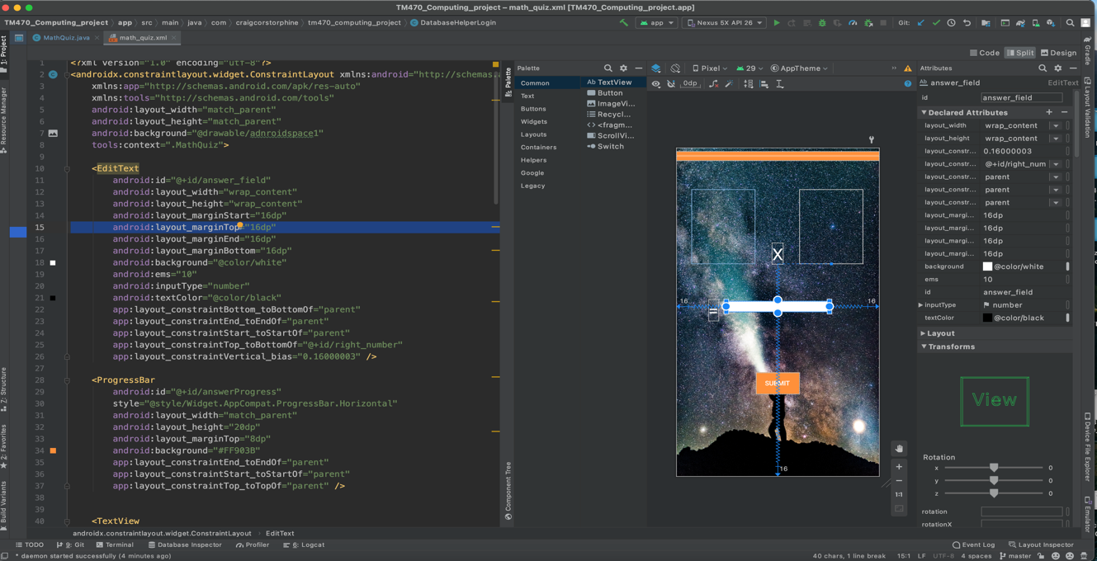*(Above) Screen shot of the activity layout for the math quiz.*

Above is the activity layout for the math quiz activity. On the left is the XML code. Some of the XML code is auto generated if elements are dragged and dropped onto the design interface on the right-hand side. On the design screen you can see the two rectangle boxes which will provide the image view for the numbers, the text view below for the input and the button at the bottom. The elements are held together with a constraint layout. You can see on the left-hand side of the panel the edit Text tag. This refers to the white box that will be used to input numbers in the activity. The code underneath the edit text tag are all the elements from position to colour as well as the id of the element which is important for tagging it to the Java code.

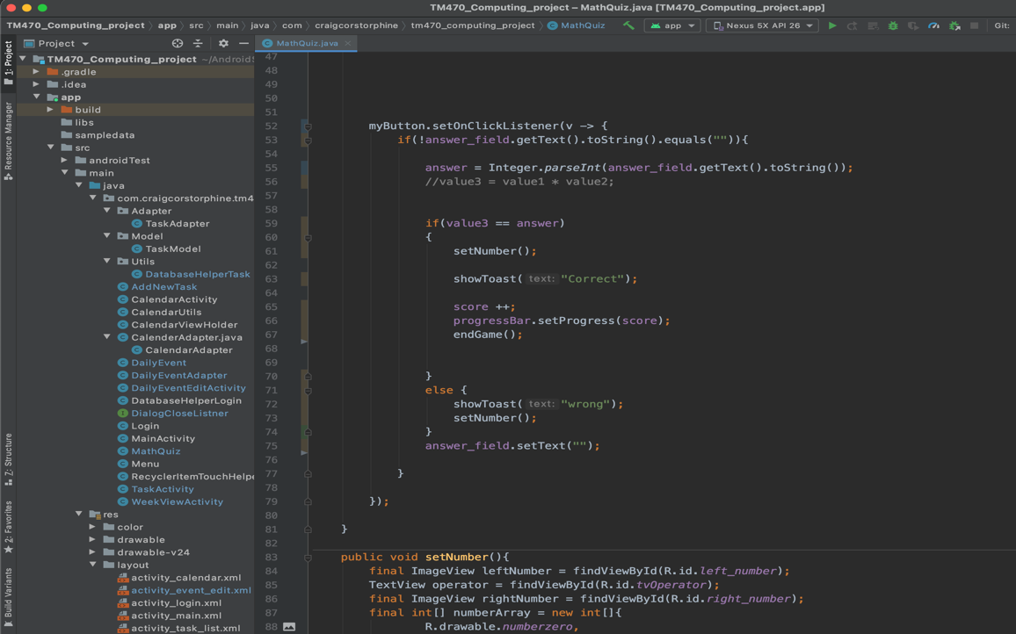

*(Above)The Java code*

Above is the java class for the math quiz. this is where the logic is performed, and the image view elements are linked to values.

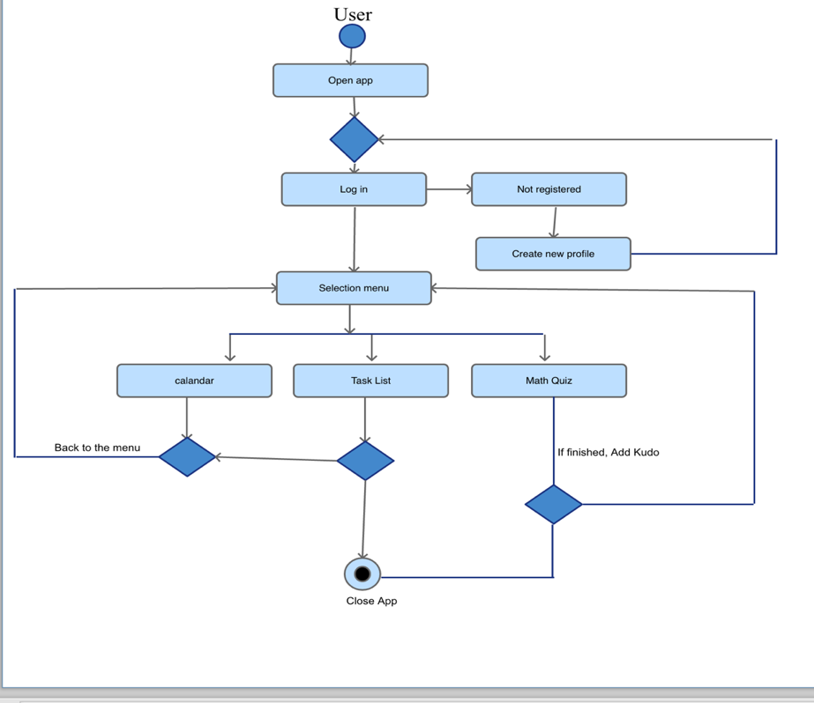

*(above) Activity Diagram*

The Activity diagram above shows the basic flow of the app. Although each activity will have more functionality than is shown, it would quickly become a mess to include it all. Following on from this I will give a detailed description of each activity and the classes it holds.

## Evidence, description, and explanation of the app

Below are screen shots of the working app so far. I developed the user interface with layout resource files which includes XML coding with drag and drop elements within the Android studio IDE. Java was then used to code the functionality. Other essential elements include the Android manifest which is an XML file which includes essential information such as tools, information from the gradlebuild files, the apps name, and its activities. I encountered a few problems with this as the project went through the first iteration. I have described the problems I encountered in a later section.

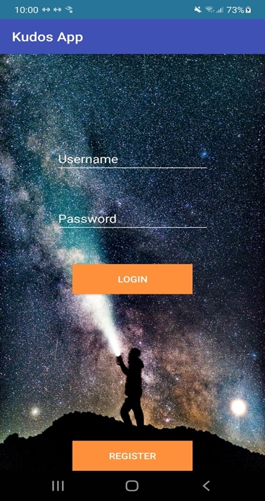

*(Above)Login Activity. Background picture free to use(@viagalactica 13/08/2019)*

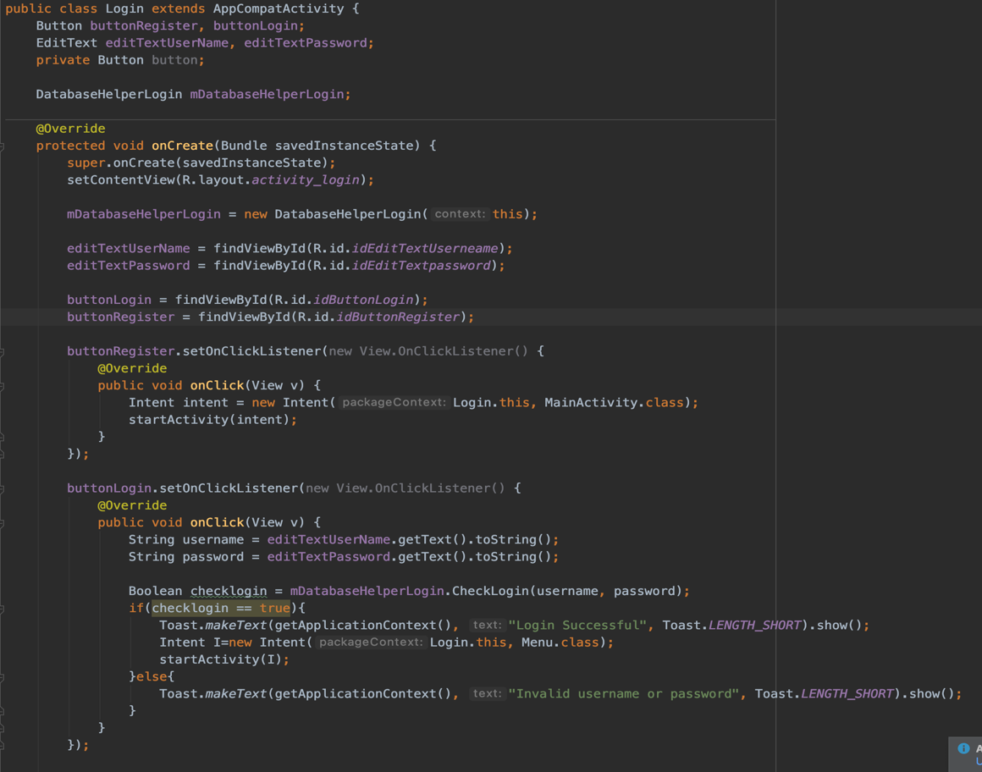

above(Login java code)

(See appendix 2 for XML layout)

The Login Activity is the first screen shown upon opening the app. This was made using a layout resource file which allows you to drag and drop various elements on the design such as button and text input fields. The login page will take you to the menu activity on successful log in or it will take you to a registration page.

As you can see in the code above, I have taken care to name variables in a descriptive way. In the first iteration of the project, I had rushed the code and naming of variable and I ended up with code that was very hard to read. A variable such as “btn1” is hard to trace to a function where something like “buttonRegister” is clearer to distinct from other buttons. It is clear it’s the registration button.

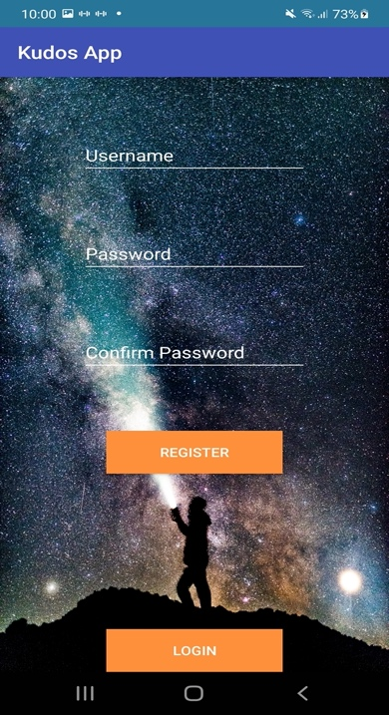

*(Above)Register Activity*

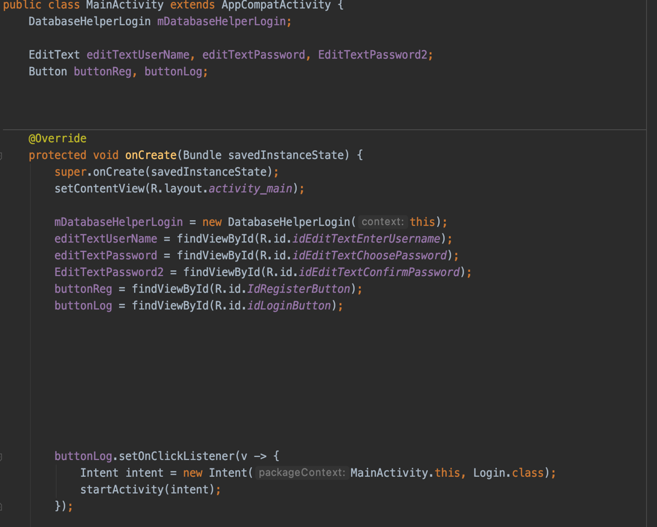

*above(Register activity java code fig1)*

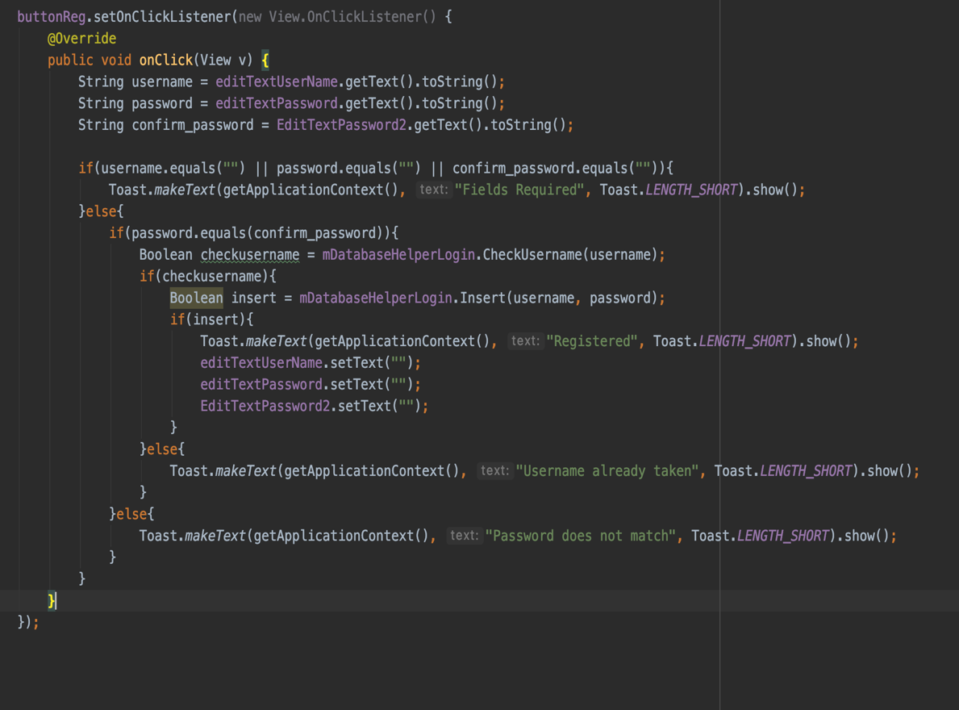

*above(register activity java code fig2)*

(See appendix 1 for XML layout)

The registration activity will enable registration using basic authentication. This uses a database through SQLite to store user details. Upon successful registration the user can then log in.

I needed a fair amount of help with the use of tutorial to code this part as I found it difficult to follow the official Android Documentation. The database functionality is written in a database helper class that was also explained using a tutorial. Anupam Chugh(07/2021)

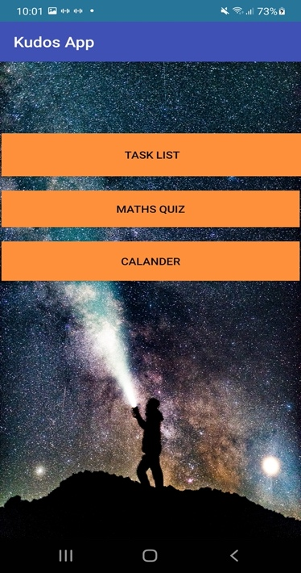

*(Above)Menu Activity*

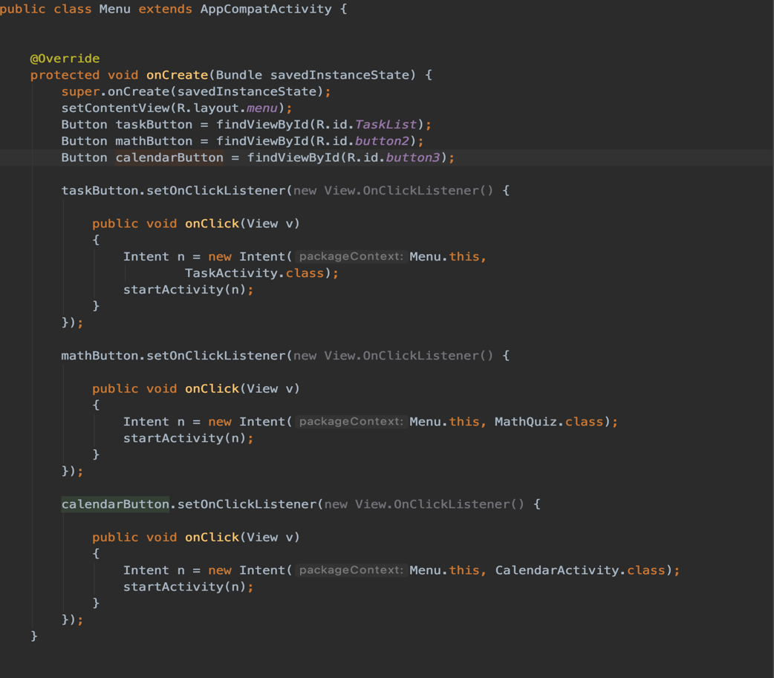

*above(This is the main menu activity java code)*

The menu activity displays 3 buttons, each taking the user to an activity.

The code above shows how the buttons connect to different activities through an on click listener and the intent functionality. This was probably the easiest part of the application to code as it just involved linking up the activity buttons using onclick listeners. This is a method used to link up java code to the activity user interface. The only problem I encountered was not included the activities in the Android manifest. Each activity must be included in the manifest to work. The manifest essentially tells the application what to include when loading up.

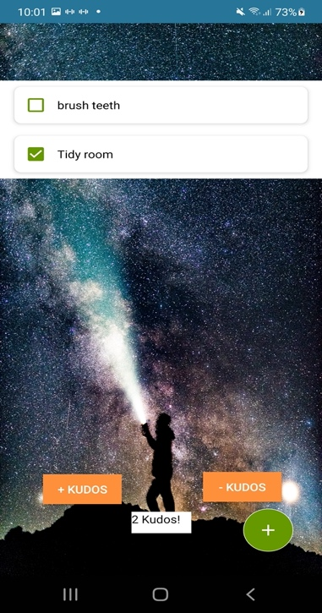

*(Above)Task list page*

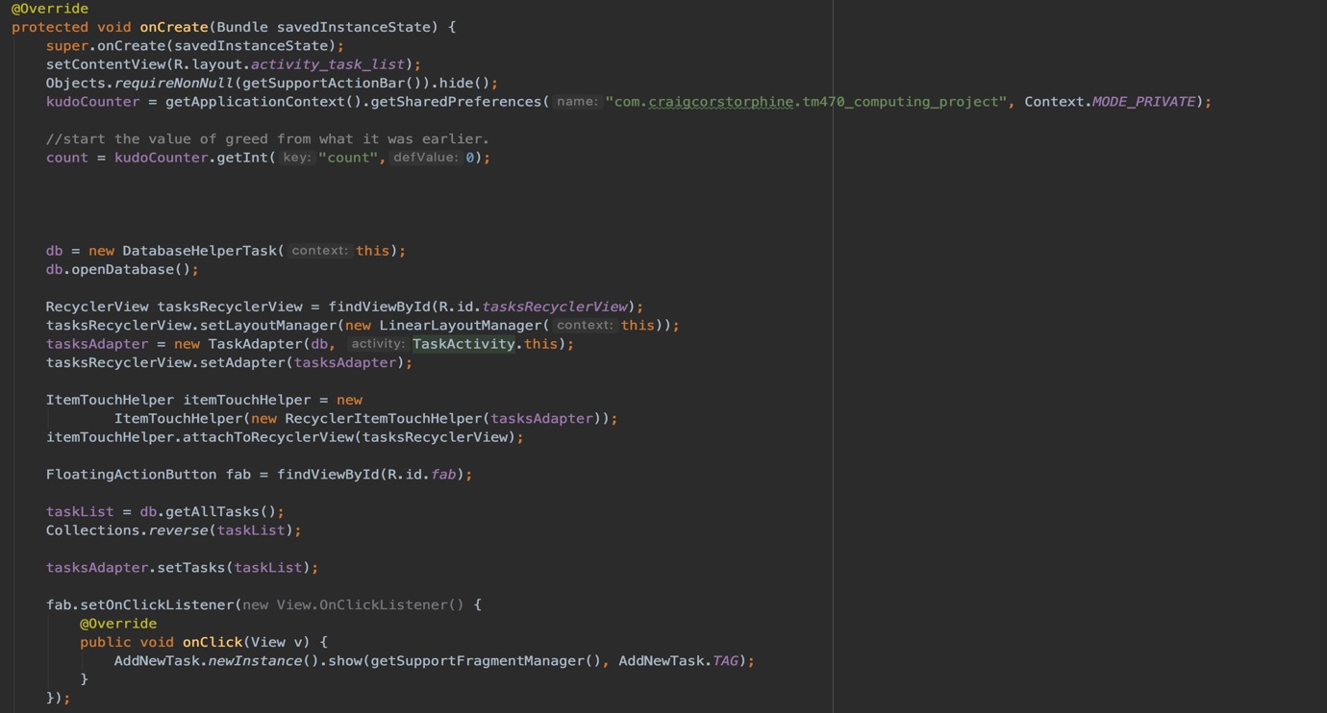

*above(task list activity java code fig1)*

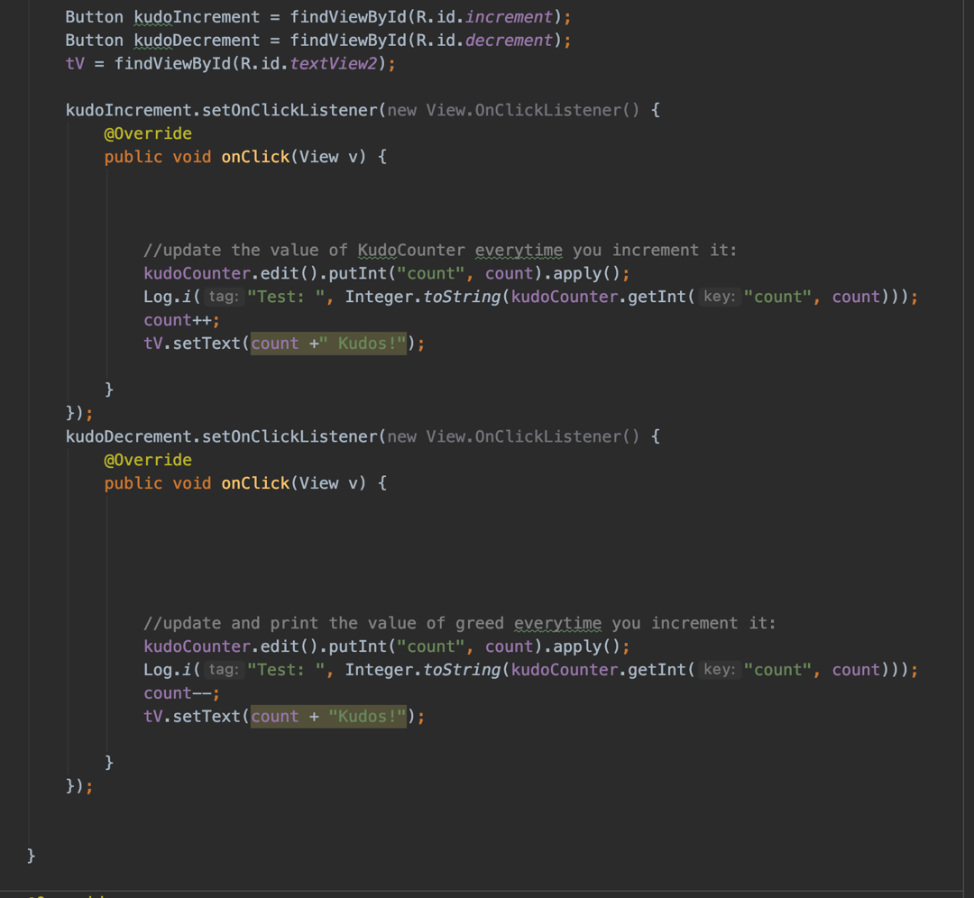

*above(task list activity java code fig2)*

(See appendix 4 for XML layout)

The task list page allows the user to add and remove tasks from the list. Completed tasks can be checked by a tick. Tasks can be added by tapping the green button on the bottom left. A recycler view is used for the list and is kept in the activity_task_list.xml file. Tasks can be edited by swiping left and deleted by swiping right on the task(recyclerview). The + and – Kudos buttons are for manually adding and removing kudos. Kudos are currently saved using androids shared preferences. This locally stores key-value data on the device and is ideal for small amounts of data, as a new table in a database can be considered unnecessary for a single integer.

Number assets(deposit Photos no date)

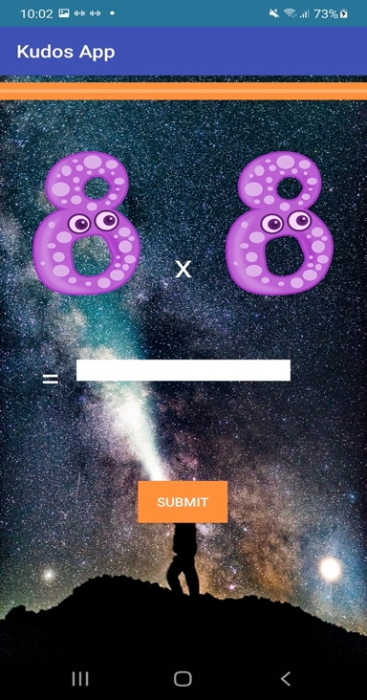 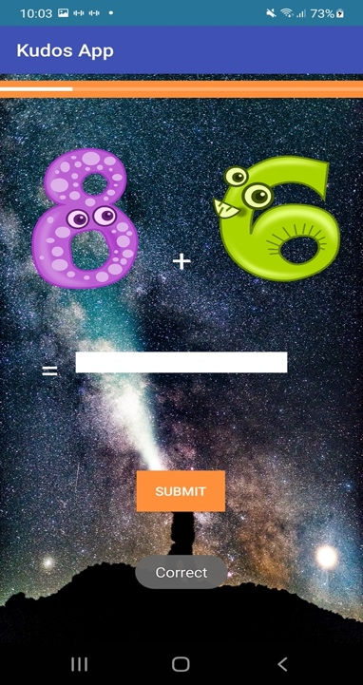

(Above)*Math Activity (Above)Math Activity showing progress bar*

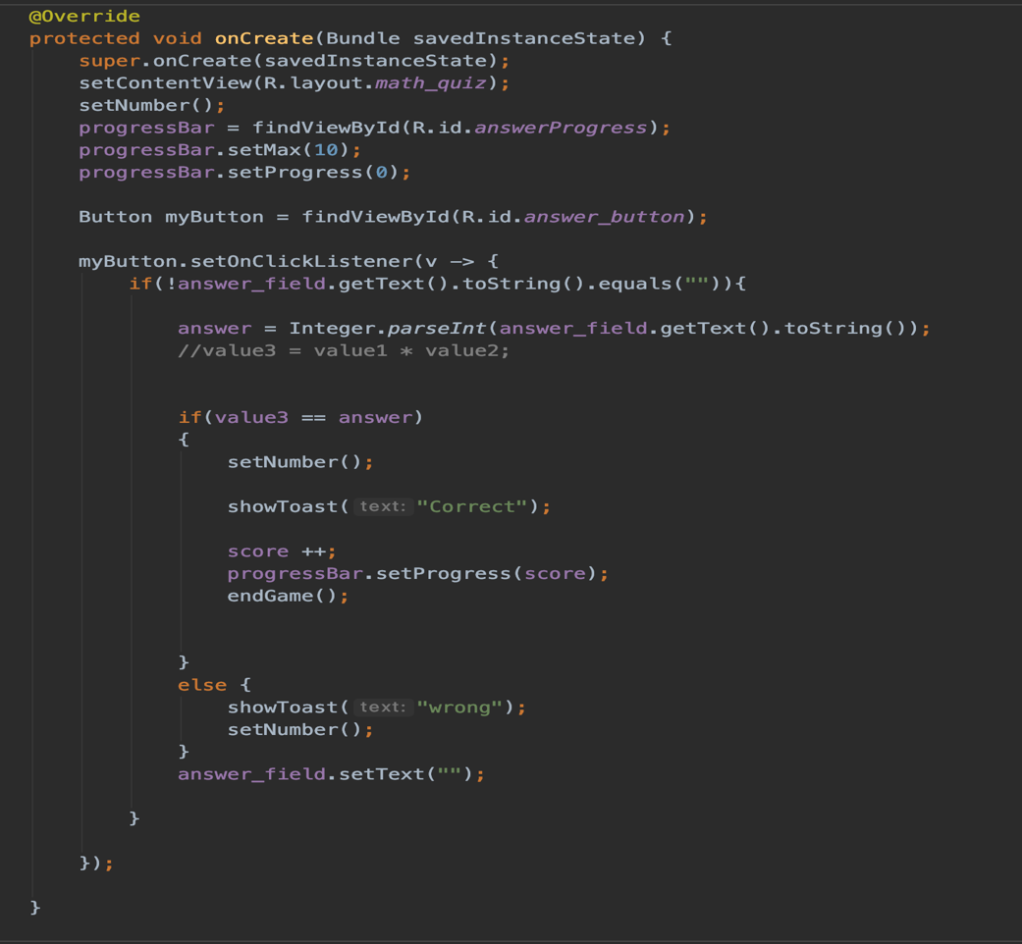

*above(math activity java code fig1)*

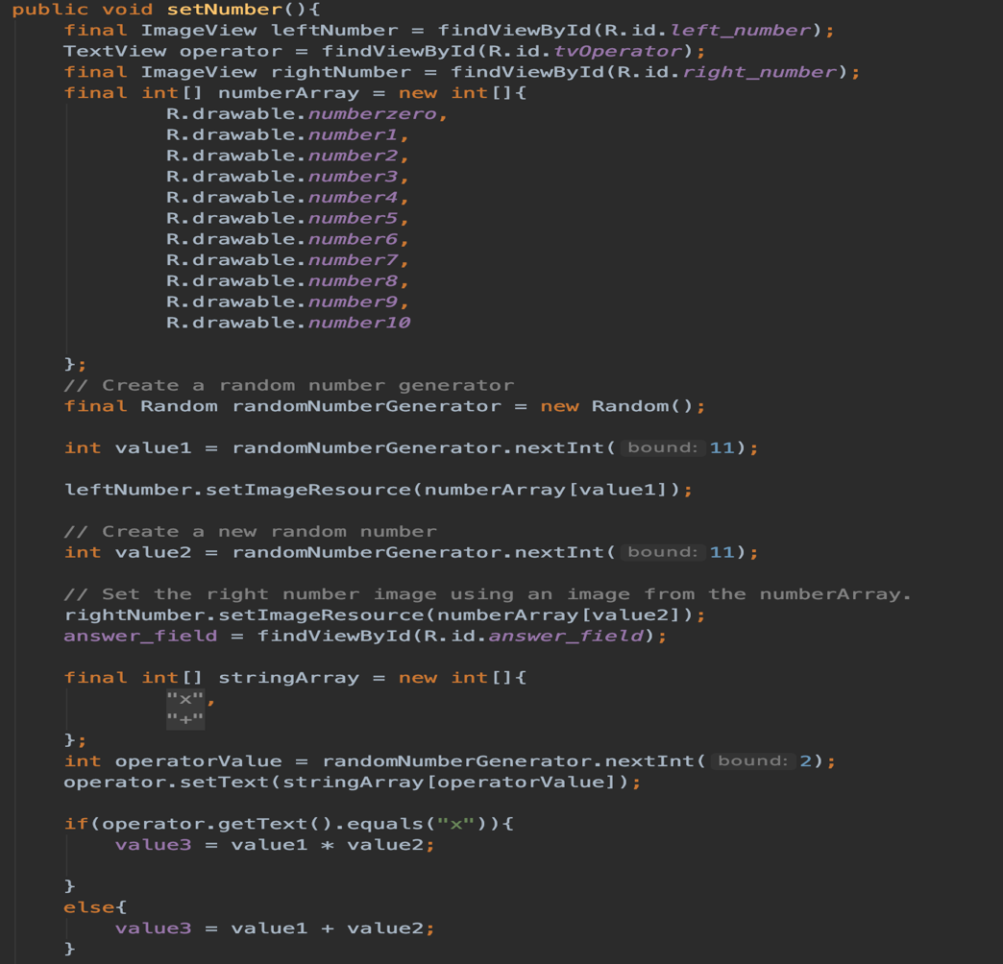

*above(math activity java code fig2)*

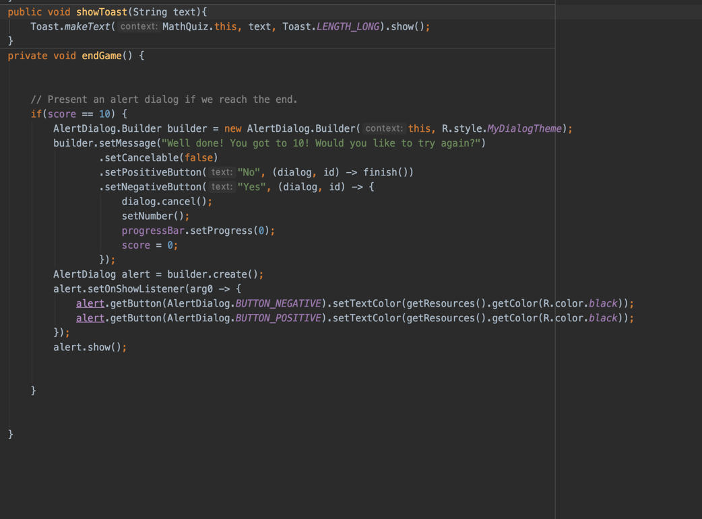

*above(math activity java code fig3)*

(See appendix 5 for XML layout)

The math activity is a simple maths test with random generated numbers as well as a random sign of addition and multiplication. Correct answers move the progress bar shown the top of the page to the end, at that point the game ends and asks the user if they want to continue or finish. Successful completion of the game will add 1 kudo to the daily total. Above you can see the java code in figs 1,2 and 3. it shows how the random generated number assets are generated as well as various dialogs and the increment of the progress bar. This part of the app was fairly easy to code, and the only real challenge was finding appropriate image assets.

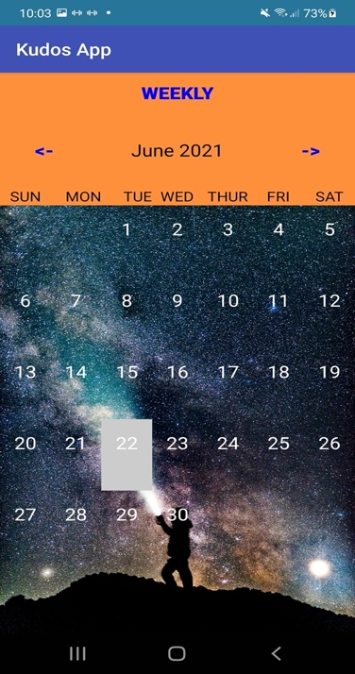 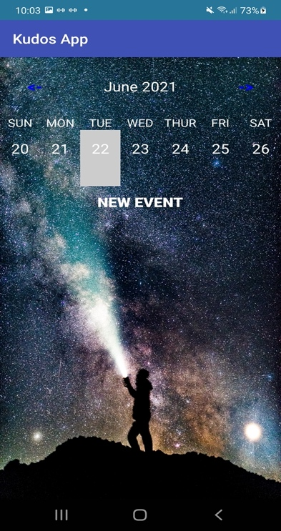

*(Above)Calendar activity (Above)Calendar Weekly view*

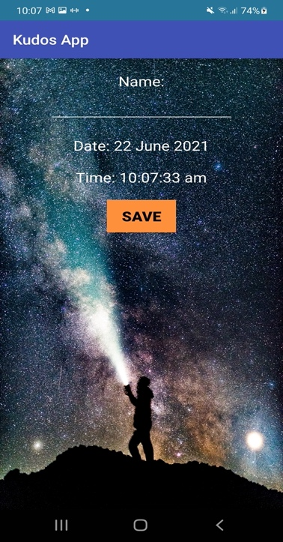 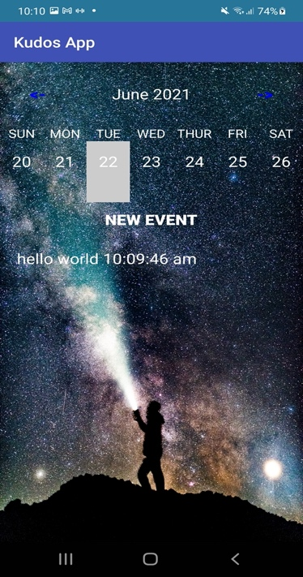

*(Above)Calendar add event (Above)New event added*

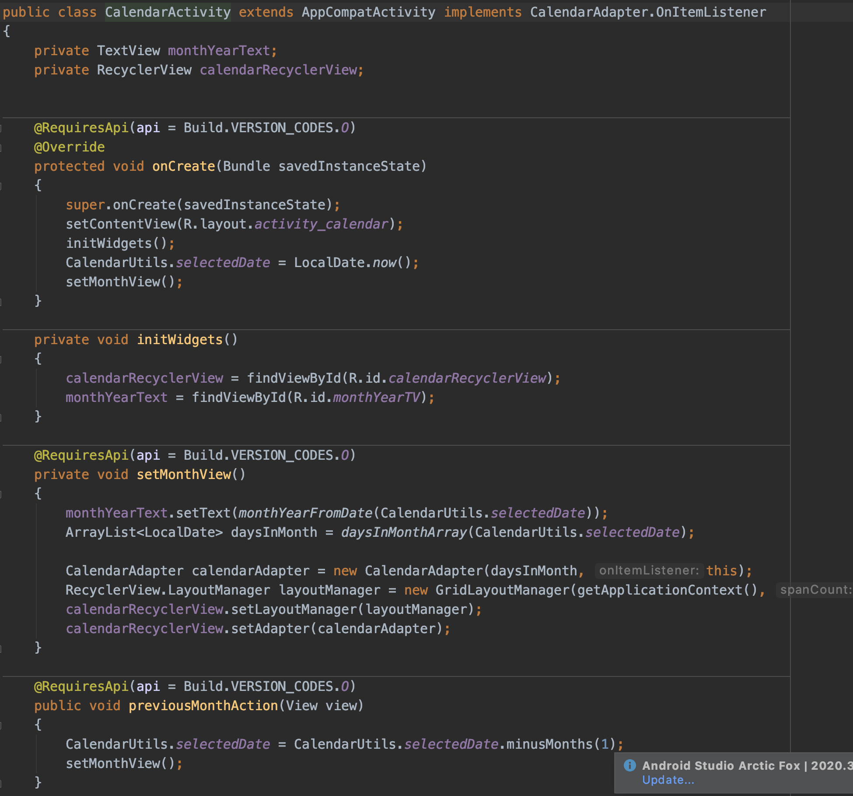

Above(this is the Java code for the monthly calendar view. I make use of an array list, and recycler views to facilitate the calendar )

(See appendix 6,7,8,9 and, 10 for XML layout)

Above is the calendar activity. Here the user can see a monthly view. By tapping on “weekly” at the top of the screen, the weekly activity will be displayed. Here the user can add a new event under “name” and then save it with the button below. As the intended user of the app, this is where I would add milestones and rewards. It will also keep a record of previous milestones.

## Java Classes implemented

Below is a table of the java classes implemented with a brief description and the purpose of them.

|  |  |
| --- | --- |
| Java Class | Description and purpose |
| AddNewTask | This is a class to add a new task that extends bottomSheetDialogFragment. This means a sheet pops up from the bottom of the screen that will contain a box to write the new task in. |
| CalendarActivity | This is the calendar activity that extends AppCompatActivity and implements CalendarAdapter.OnItemListner. This class sets the calendar views including monthly and weekly. as well as previousMonth and nextMonth methods for changing monthly views. |
| CalendarAdapter | CalendarAdapter extends a RecyclerView Adapter with the CalendarViewHolder. This class creates an Array list to hold the days and display what day of the month it is. |
| CalendarUtils | This Class formats the Calendar to local date and time. The library of dateTimeFormater is used to format the days, months, years, and time. |
| CalendarViewHolder | This is the view holder for the calendar. It displays the days of the month in the cells. |
| DatabaseHelperLogin | The database helper in SQLite for the login activity. it declares the database name as well as what the content values will be with the insert method. It also has checkUsername and CheckLogin Boolean methods. |
| DatabaseHelperTask | Just like the DB helper for the log in, but it helps set up the database for the task list activity. It contains methods update task and delete task. |
| DailyEvent | A Class to add a daily event such as a reward and kudos earned that day. |
| DailyEventAdapter | Adds the event into the daily cell. |
| DailyEventEditActivity | Sets the date, time, and name of event |
| Login | Links up to the activity login view to give it functionality by declaring button variables and has added Toasts tell the user if login was successful or invalid. |
| MainActivity | The main activity in this app is for the register function as it was the first class that was built. This Class allows the user to register with the help of the Database helper Login Class. |
| MathQuiz | The class with all the functionally for the maths quiz activity. A number array is used and linked to number pictures through the drawable resource files. The numbers are randomly generated to create a solvable math question. The operator is also randomly generated. |
| Menu | A class that linked the menu buttons to other activities. |
| RecyclerItemTouchHelper | A class that allows the swiping of the task activities to edit or delete. |
| TaskActivity | This Class displays all the tasks as well as the editable kudos. |
| TaskAdapter | Facilitates editing, setting, and deleting of tasks |
| TaskModel | This class has the getter and setter methods used in the task classes |
| WeekViewActivity | This class has the functionality of the week view activity. |

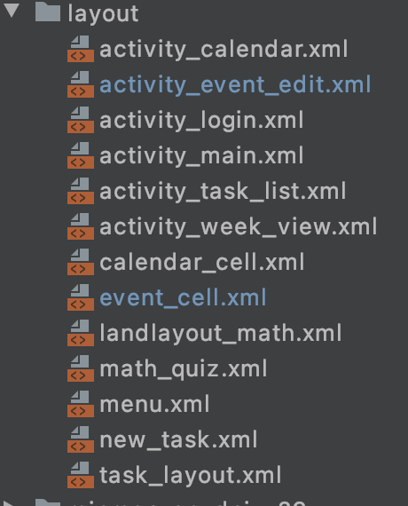

*(Above) These are the layout files I created for the project. For most of the project the layout files were created first with the functionality add after with the java code.*

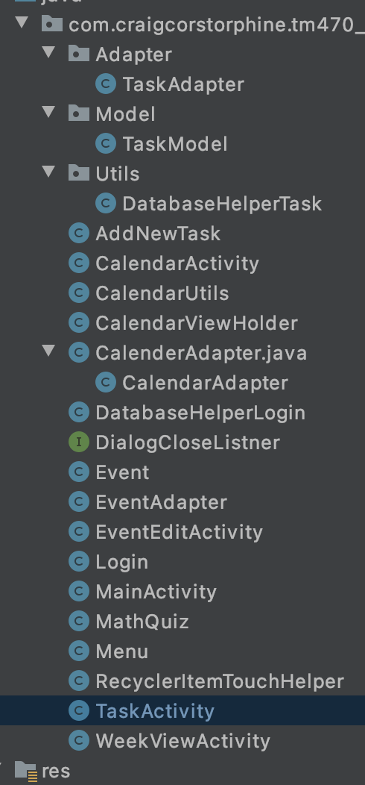

*(Above) A list of All the java classes that have been implemented.*

## Problems encountered

SQLite proved to be challenging at first, and although many problems were encountered at first, the project finally came together. There is perhaps not the need for two database helpers, but by that point the code was starting to get messy and thought best to implement two separate database helpers to keep the classes clearer. The DatabaseHelperTask Class is for implementing and saving the tasks in the task activities and the DatabaseHelperLogin is used to store the registration details and have the login details checked with the database upon logging in.

The first major issue turned out to be a simple fix. I could not get the activities to link up to each other from the menu, even though I had initiated it in the java code(see below)

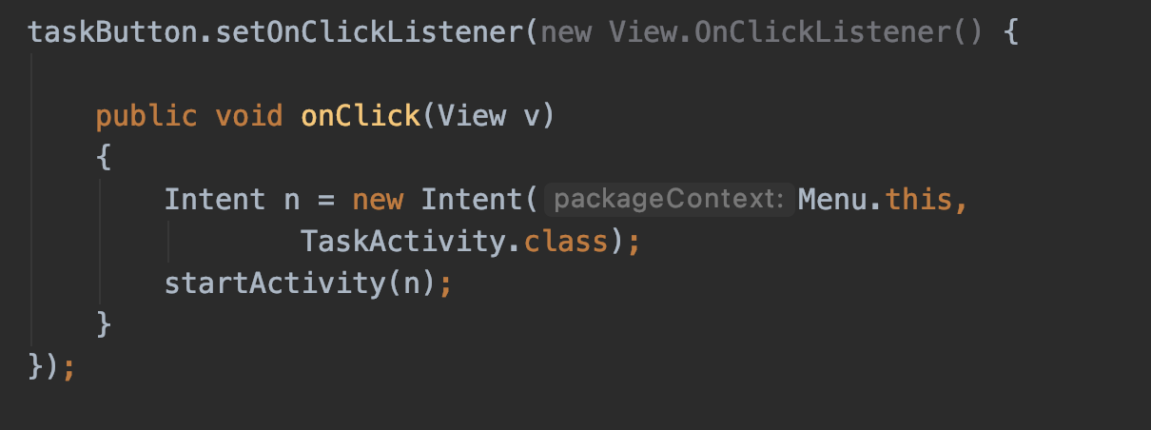

*Above(Java code used to move from the Menu activity to the Task Activity)*

The problem was not with the Java code, but within the Android Manifest. I had not included the new activities in this. See the updated Manifest below that includes All the relevant activates under the <activity/> tag. The menu, TaskActivty, mathQuiz and calendar activity are all included there.

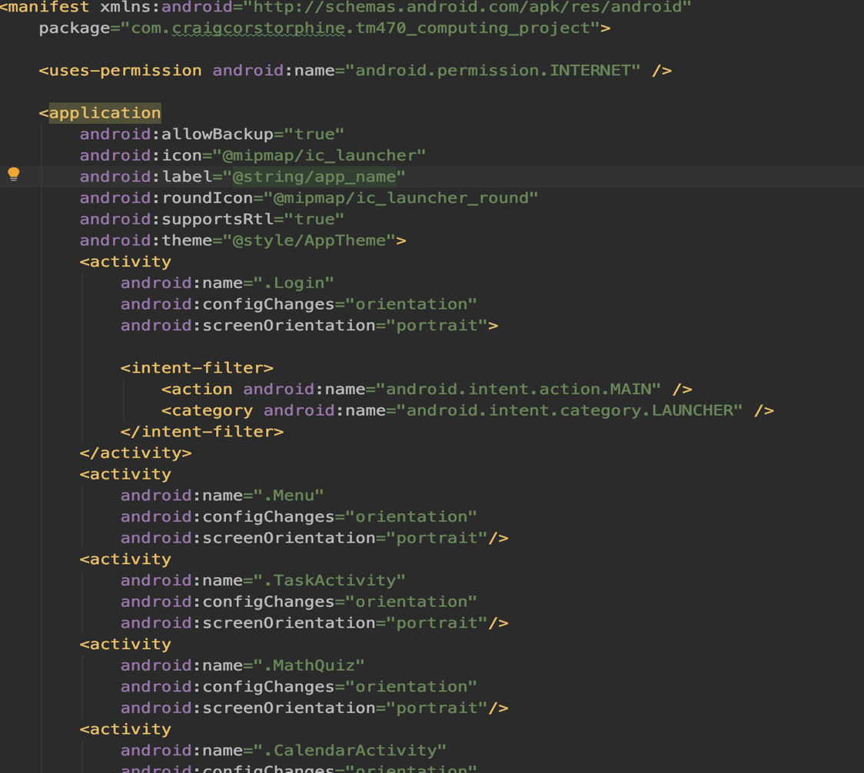

*(above)Updated Android Manifest*

The other issue encountered was getting shared preferences to work correctly. I could not quite figure it out from the android documentation. The problem was I had declared the shared preferences interface locally when it should have been a class variable.

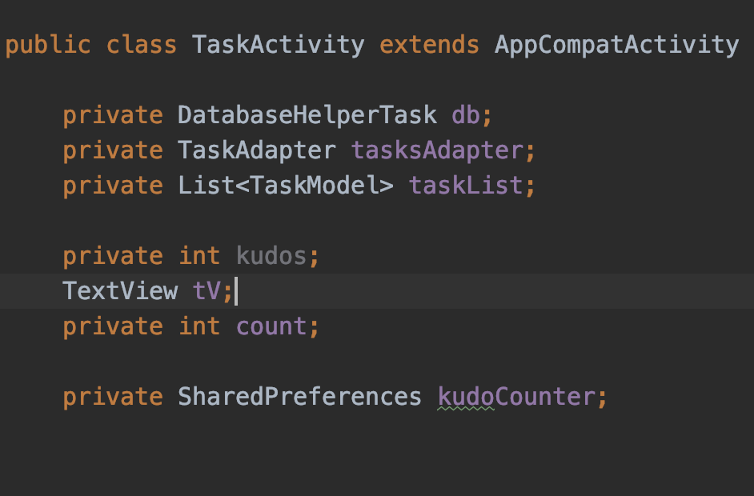

*(above)This is where the shared preference interface was declared as kudoCounter.*

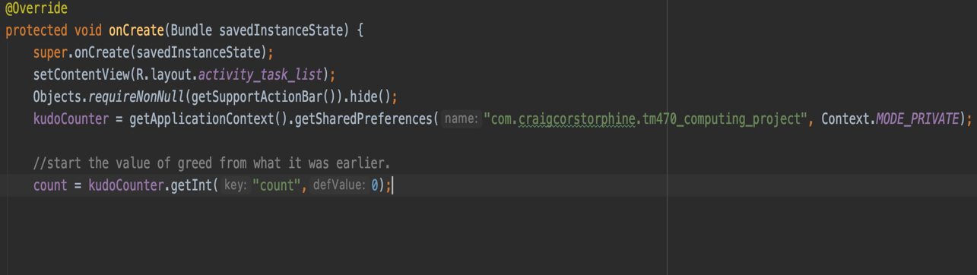

*(Above)Implementation of shared preferences*

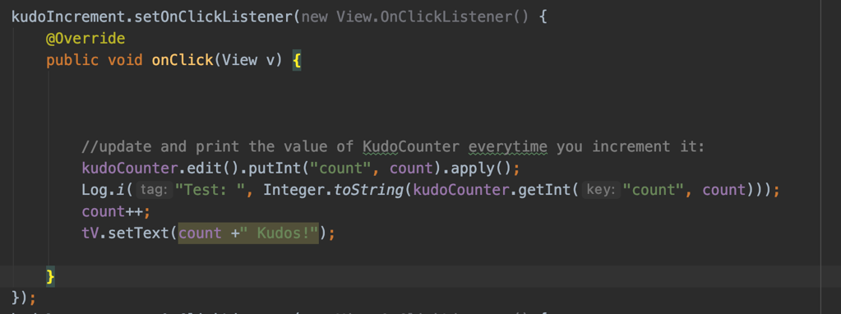

*Above is the implementation of it into the onClick listener. Log.i is included for testing.*

Another issue during the first iteration was the use of poor naming conventions. This led to confusing code and classes. It also involved the deletion in two classes and the refactoring on others. Effort has been made to carefully name future classes and variables in a more descriptive manner resulting in a far more successful second iteration.

## Testing the app

This table documents user acceptance tests after the second iteration. There are likely to be other issues or tests needing done after the third iteration, but the following tests are for the main functionality and scope of the application. It is likely that there are many hidden bugs within the app that will be uncovered with more testing. The third iteration will address these if and when they arise.

|  |  |  |  |
| --- | --- | --- | --- |
| Test | Tested | Description | Outcome |
| 1 | Register activity button | Upon tapping the register button, the user is taken to the register activity | Accepted. The register activity is displayed |
| 2 | Complete register | Fill out the register form with matching passwords. | Accepted. Register dialog box displayed |
| 3 | Unsuccessful register | Password doesn’t match with the confirm password | Accepted. “Password does not match” is displayed in a dialog box |
| 4 | Username already taken | Username already taken | Accepted. Upon trying to register with an already in use username a dialog box appears “Username already taken” |
| 5 | Login | Enter username and password to login | Accepted. “Login successful” is displayed |
| 6 | Failed log in | Wrong details entered | Accepted. “Invalid username or password” is displayed. |
| 7 | Task List Activity | Button takes user to the task activity | Accepted. Task activity is on display |
| 8 | Add Task | Add task button if pressed | Accepted. Task successfully added and saved |
| 9 | Delete Task | Delete task by swiping left on the task | Accepted. Task successfully deleted from list |
| 10 | Edit Task | Edit task by swiping right on the task | Accepted. Task listed was edited successfully |
| 11 | Add Kudos | Press the +Kudo’s button | Accepted. Kudos added |
| 12 | Remove Kudos | Press the – Kudo’s button | Accepted. kudos subtracted |
| 13 | Maths Quiz Button | Button takes user to the math quiz activity | Accepted. User is taken to the Math quiz activity |
| 14 | Correct answer | Answer a question correctly displays an alert tell the user “Correct” and increments the progress bar by 1. | Accepted. displays correct alert and progress bar moves by 1 point. |
| 15 | Wrong Answer | Answer a question wrongly and alert tells the user the answer is “wrong”. The progress bar does not move | Accepted. displays the “wrong” alert and progress bar does not move |
| 16 | Finish the game | Progress bar reaches the end after 10 correct answers. A dialog box asks to try again with “yes” or “No” option. Yes, starts another r game and no takes user back to the menu screen | Accepted. Both options at the end do as intended and all question logic appears to be correct. |
| 17 | Calendar button | Button taking the user to the calendar activity. | Accepted. User successfully taken to Calendar |
| 18 | Weekly view | Weekly tapped to access weekly view | Accepted. Weekly view accessed by user |
| 19 | New daily event | Add a new Daily event/reward | Accepted. Daily event/reward added |
| 20 | Change month | Toggle through months with arrow buttons | Accepted. User can change months. |
| 21 | Change week | Toggle through weeks with arrow buttons | Accepted. User can change weeks. |

## 

Test was done live on an Android device. The testers were present, and they were walked through the steps of how to use the Application. They were then given the user tests that were easy to follow, and feedback was recorded. User Feedback concerning other issues are addressed int eh next section.

## User Feedback

User feedback has been generally good, and they are happy with the general set up of the app. There are however some changes that will be made following feedback. These will be made in the third and final iteration.

|  |  |  |
| --- | --- | --- |
| Feedback issue number | User feedback | Proposed solution |
| 1 | The input text for login and register activity’s clashes with the background | Change the text colour to white. |
| 2 | Did not notice the progress bar at top of the screen on the math quiz activity | Widen the thickness of the progress bar and add text to indicate what it is. |
| 3 | Calendar view needs to be intuitive on what its function is. It’s not obvious on how to get to the weekly view and to add daily event/log/reward. | Add more descripted text to the app and make responsive points more obvious. |
| 4 | Change the background. The background clashes with certain activities. | Change the background to a generic single colour. |
| 5 | Would be nice to have a welcome screen as app loads abruptly. Would give the app a more professional feel | Add a splash screen to start the app. |
| 6 | Change register function to valid email address only to prevent child access | Modify the code to implement valid email address only. |
| 7 | Stop the kudos from going into negative numbers. | Adapt the code to stop the kudos at 0 and prevent it from going into negative numbers. |

Further User discussion.

It was also discussed whether the app should reset/delete the tasks for each day. This however seemed counterproductive for the users situation as almost all the tasks would be repeated daily. This will likely be different for other users and the general public. It may be an option to implement an option to delete or reset tasks after every day if the app is released to the general public.

## Final iteration work to do

The third iteration will involve implementing a daily notification system. This will come in for of a reminder that can be set for a specific time to check off tasks or add new ones. This will help with consistency for the user. It should also prompt the user to add daily events which should be used to document rewards, passed rewards and the number of kudos earned on that day.

Another implementation will be a reset feature for the kudos. This will be a function to rest the kudos at the end of every day. The user feedback issues 1 to 6 will be addressed/fixed and it will go through the last set of testing to ensure the final app is fit for purpose.

Lastly the ability to change the difficulty setting on the math quiz app should be implemented. The multiplication question are out of the grasp of a 4-year-old, so a toggle between multiplication and subtraction as well lowering the range of numbers are options.

## Final iteration

The Third iteration has been a smoother process. Using the NotificationComapat builder. This was easy enough to implement in the project. Resetting the kudos feature was also straight forward and involved resetting after midnight. I have not implemented a feature to disable that however. That is something to consider in future development.

I have struggled with the look and feel of the app on this iteration. It may be the case that It need better assets to add to the design, but at the moment if feels slightly like a mishmash of features. I will consider plash screens/load screens in future iterations.

Lastly, I implemented a difficultly setting into the app for the math quiz. This uses 3 different settings. The first is just Addition of the numbers 0 to 5, the second is addition of numbers 0 to 12 and the highest difficultly is addition and multiplication of numbers 0 to 12.

# Legal, Social, Ethical, and professional

As this project is developing an app for personal use there are few concerns to cover. I will outline any possible issues in the table below.

|  |  |
| --- | --- |
| Issue | Concern |
| Legal | Legal issues for the project will concern the use of software. All software used is either free or open source and nothing had been used illegally. |
| legal | Data that is stored is stored on the user’s device only. There is no risk of data breech whilst using the app and no data is transferred over the internet. |
| Social | As this is a small personal project there is very little impact socially. If the app is released to the wider public, social implication will need to be considered. |
| Ethical | Like anything the app could be abused and used not for the intended purpose. For example, it could theoretically be used to punish or record failings that may damage the self-esteem of a child. This is obviously something to consider when releasing too wider public |
| Professional | The project has been carried out in a professional manner and stakeholder’s and testers have been treated with respect and curtesy. |

# Review of current stage of project work

I am currently pleased with the progress I have made on the development aspects of the project; however, this has not come without problems. I had significant problems getting to grips with SQLite and successfully implementing it into the application. Although the Android documentation was helpful, I had to seek out other learning resources to help men implement it. I did however get there in the end by implementing by setting up two database helpers for two different tables.

I have also started to think that the Login and register aspect may be redundant for the app, but I have been reassured from user feedback that it would prevent being tampered with by the user’s child. I should however change the register activity to only accept a valid email address instead of a username. It is very unlikely that a child of the ages 4 to 8 would have an email address. This would need to be something I thought more about if I was to release the application to the public.

I think my lack of design experience shows in the app as well. I’m in agreement with the users that the look and feel can be improved to make the user experience more intuitive. Regardless of the problems I’ve encountered I am relatively happy with the current progress and without too much work the app can be improved in the next iteration.

## Project Management

I believe project management is one of my main weaknesses when it comes to this project. Although I developed a schedule I seldom stuck to. I instead tended to do work in sprints. I would work intensely for 3 or 4 days then stop for a period and repeat. This was mostly due to personal circumstances as I didn’t consider certain scenarios. My daughter’s nursery closed for 10 days due to a Covid outbreak meaning I was the primary child carer. This made project work very difficult during that time. This resulted in periods of intense work(sprints) to catch up. I also had a delay in starting the first iteration of the project development due to an EMA of another module. I also failed to take this into account resulting in a sprint for the first iteration.

I am however pleased that I finished the first and second iterations of the project on schedule. I have also successfully kept notes of problems and difficulties during the development process which has helped me plan out the TMA and evaluate how the project work has progressed.

In terms of project lifecycle choice, the iterative method was the correct one. Although the in the first iteration the whole app was incomplete, enough of it was built to produce some meaningful user testing. After the second iteration a good outline of the app had been built with user testing giving valuable feedback for the final iteration. Looking back, it could have been viable to use the incremental method or perhaps a combination of iterative and incremental, but I feel it is best not to over complicate the project management aspects.

## Assess risks to project completion

|  |  |  |  |
| --- | --- | --- | --- |
| Risk | Impact | Likelihood | Mitigation |
| 1.The Users reject the app | H | L | Risk can be managed by an early prototype and user testing. This will ensure the app is designed around user preferences.  Testing after each iteration will be essential to improve UX and to gain valuable feedback from the stakeholders and implementing it will increase chances of users embracing the app. |
| 2.Loss of project data through personal hardware failure | H | L | Loss of project data through personal hardware failure  This is a very possible risk, so it is essential that I have everything backed up. It is something I will do after each work session. A flash drive and perhaps a cloud storge back up too. |
| 3. Personal illness or family issues | M | L | Common illness or other more serious issues may arise, So I have scheduled more time than I usually would for certain tasks and iterations to ensure I have some leeway if the worst were to happen. |
| 4.Not enough time to fulfil project scope | M | M | As unlikely as this is to happen it can be solved by adjusting the scope. I will likely know for sure by the time I have completed the first iteration. One way to mitigate this will be to cut back on other commitments temporally until project work has be caught up with or is back on course. |
| 5. Project Scope is unmanageable | H | L | The scope of the project has been researched and defined. Nothing has been considered to advanced or beyond the capabilities of knowledge. |
| 6. Scheduling clashes and other modules to complete. | L | L | Majority of other module work should be completed in time to concentrate on project development |

Addressing the risks above

|  |  |
| --- | --- |
| Risk | Addressing the risks above |
| 1 | At this stage the primary user has had the opportunity to test the app and give feedback. This has dramatically reduced the risk as feedback is being received. The app is being tailored to the users wants and needs. |
| 2 | This risk has been reduced and managed by using version control. the project has been uploaded to GitHub at regular development milestones, as well as having a flash drive safely stored away from the computer. |
| 3 | This risk occurred in some sense that my daughter’s nursery was closed for 10 days due to a Covid outbreak. I managed the risk by working intense sprints to catch up with project work. |
| 4 | This risk has significantly eased as much of the development work has been completed. The last iteration requires development work than the first two. |
| 5 | Although the project is very challenging, nothing has seemed completely out of reach in terms of scope. |
| 6 | A clash of modules was an issue at the start of the development process meaning work on the app was delayed by two weeks. Intense periods of work followed to get the project back on schedule. |

# Review of personal development

I believe so far this has been a mostly positive experience considering how many frustrating moments I’ve had getting code to work as it should. I have acquired skills in implementing databases and other data storge techniques into apps. I feel I have also become competent in the use of android studio. The main area of improvement needed however is to learn what happens under the hood and the background workings of the development process. I sometimes feel that I know how to implement something well, but not always with the knowledge of why or how it works. This is something I want and need to work on. Another skill I would like to improve on is the UX. I think it is one of my weakest areas and user feedback has provided me with some good points to work on.

My project management skills could be improved as I very rarely followed the schedule. This was mainly due to events outside of my control (covid out-brake) and I did feel I managed to handle that well. The risk management and mitigation helped as I had planned enough time in case of said events such as covid shutdowns and having to focus more on childcare for extended periods of time. If I was being completely honest though, even if there were no restrictions on project time due to covid my schedule would likely still be erratic with periods of intense work and periods of being less productive.

Having said all that, I have managed to finish all TMA’s and project work before deadlines. I have finished the app to an acceptable standard and the EMA report is due to be finished well ahead of schedule.

In terms of this project as a whole I believe I have tackled it to the best of my ability. I was worried during the first stages as I struggled to find a project problem with enough scope, but after a few conversations with my tutor my project started to take shape and develop into what it is now.

Areas I have mostly struggled in have been the reports (TMAs) and what specific information to include in them. I feel like I am just getting to grips with that now, but it’s an area I need to work on. I feel I performed well with self-management and making the necessary sacrifices to catch up with the development work and the TMA. This included extended periods of work, early morning sessions and a temporary sacrifice of family and social time. I have shown that when I have deadlines approaching, I can increase productivity significantly. It could however suggest that I need to be more consistent, meaning I would avoid the need for such bursts of productivity.

(@viagalactica 13/08/2019) <https://unsplash.com/photos/0SqUthjger8>

(Android platform documentation, figure 1, No date) <https://developer.android.com/codelabs/android-room-with-a-view?index=..%2F..%2Findex#1>

(ClearBridge Mobile no date) <https://clearbridgemobile.com/benefits-of-native-mobile-app-development/>

(Lucid chart team no date) <https://www.lucidchart.com/blog/pros-and-cons-of-waterfall-methodology>

([razormist](https://www.sourcecodester.com/users/razormist)  4, 2021) <https://www.sourcecodester.com/android/12151/android-simple-registration-and-login-application.html>

Anupam Chugh shared pref tutorial no date( <https://www.journaldev.com/9412/android-shared-preferences-example-tutorial>)

Anupam Chugh(no date)(<https://www.journaldev.com/9438/android-sqlite-database-example-tutorial>)

Clean Code(Robert C. Martin(2009)

deposit photos, no date(<https://depositphotos.com/stock-photos/numbers-icons.html>)

Gantt chart(designed by team Gantt(no date) <https://prod.teamgantt.com>

Save data using SQLite(No date)<https://developer.android.com/training/data-storage/sqlite>

Ganit Richter, Daphne Raban, Sheizaf Rafaeli(10,2015) 2.4.3 Goal Setting Theory <https://www.researchgate.net/publication/283211242_Studying_Gamification_The_Effect_of_Rewards_and_Incentives_on_Motivation>

# Appendices

## 1

Register activity

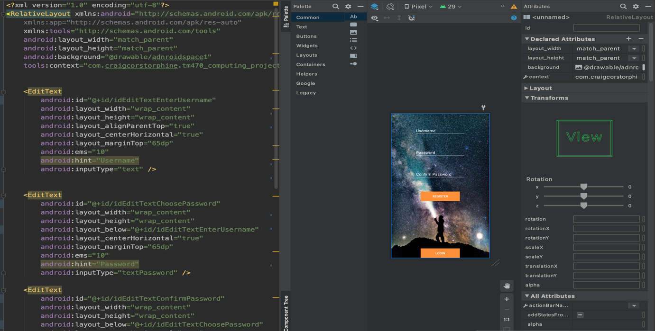

## 2

Login activity

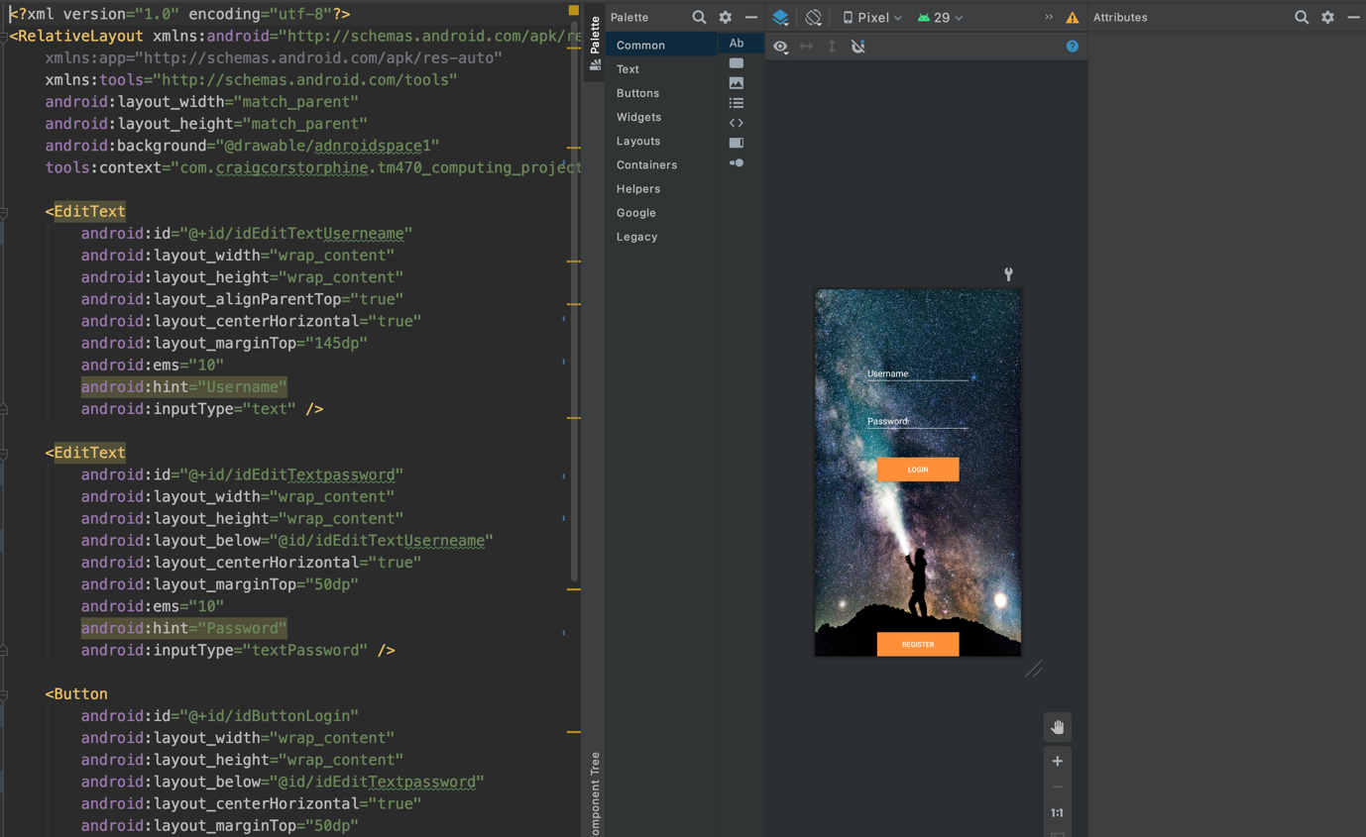

## 3

Menu activity

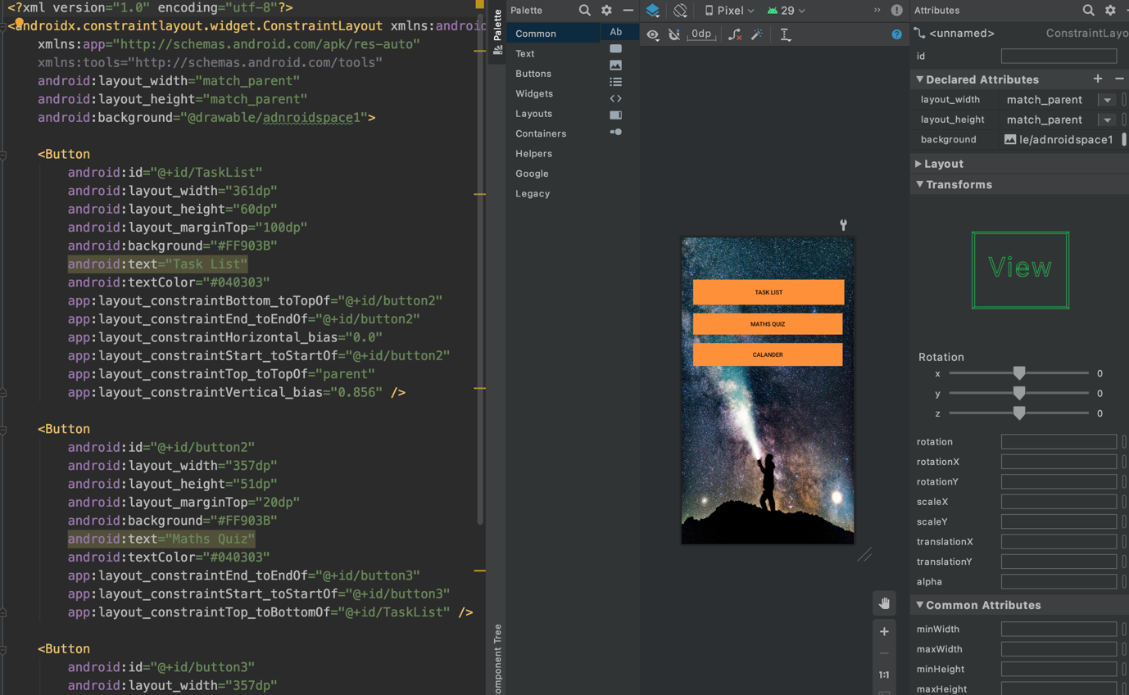

## 4

Task list activity

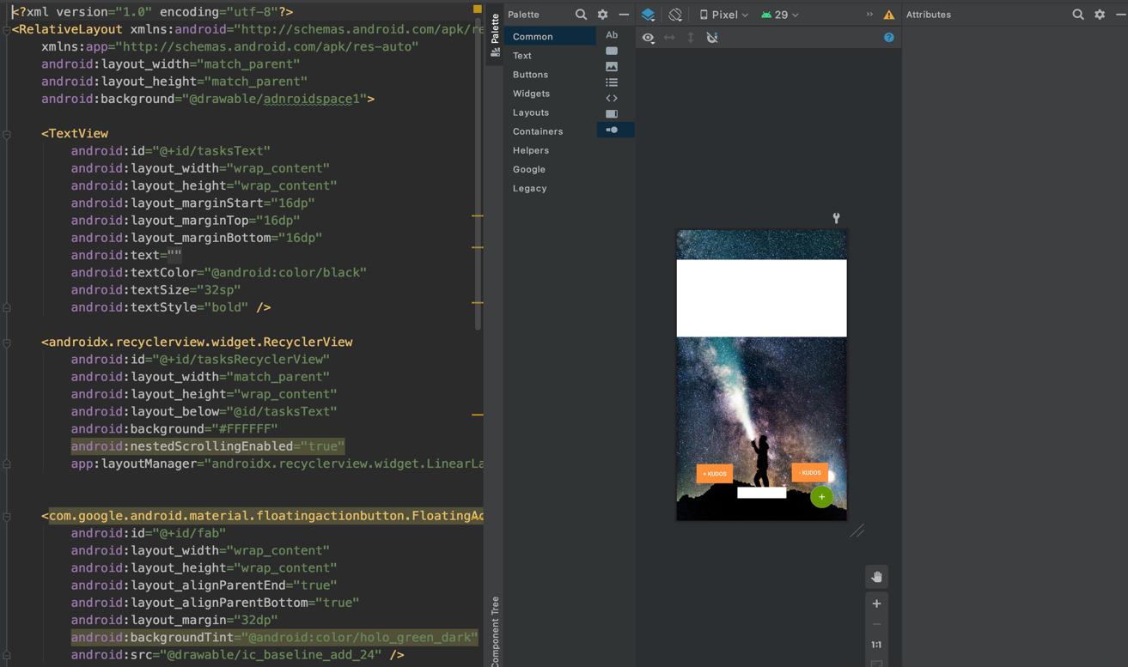

## 5

Math activity

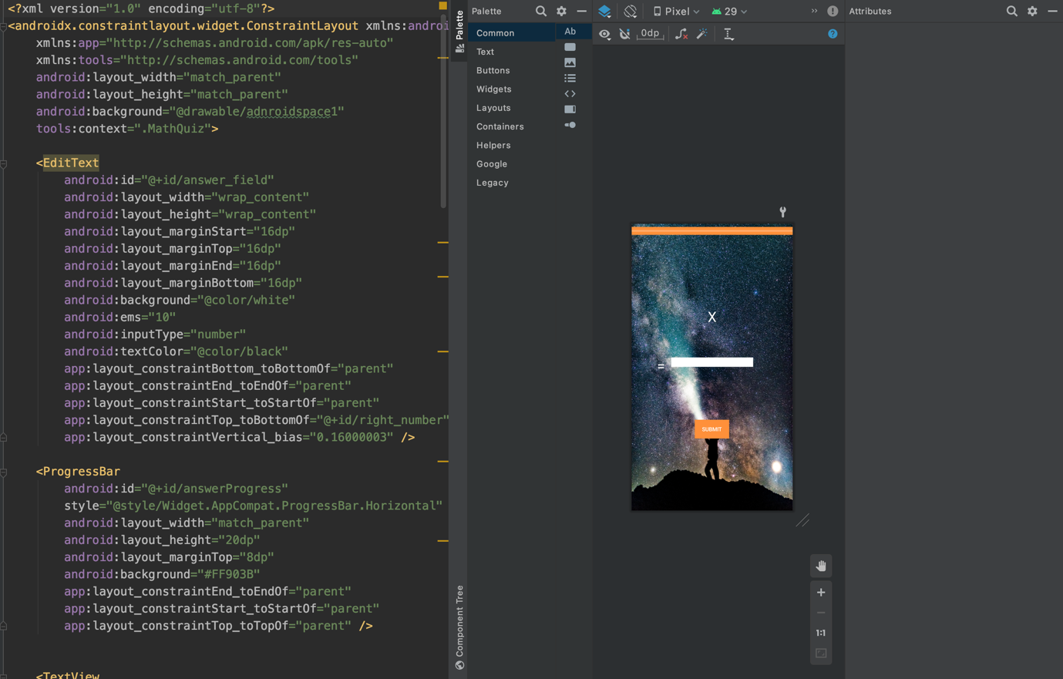

## 6

Calendar activity 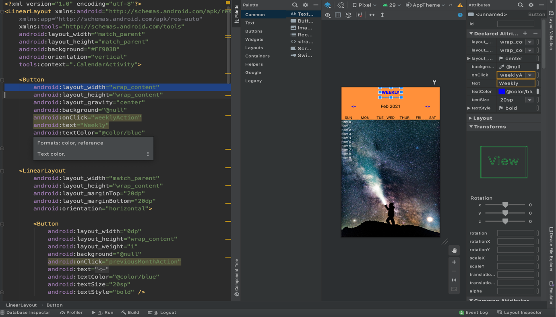

## 7

Calendar activities edit daily event

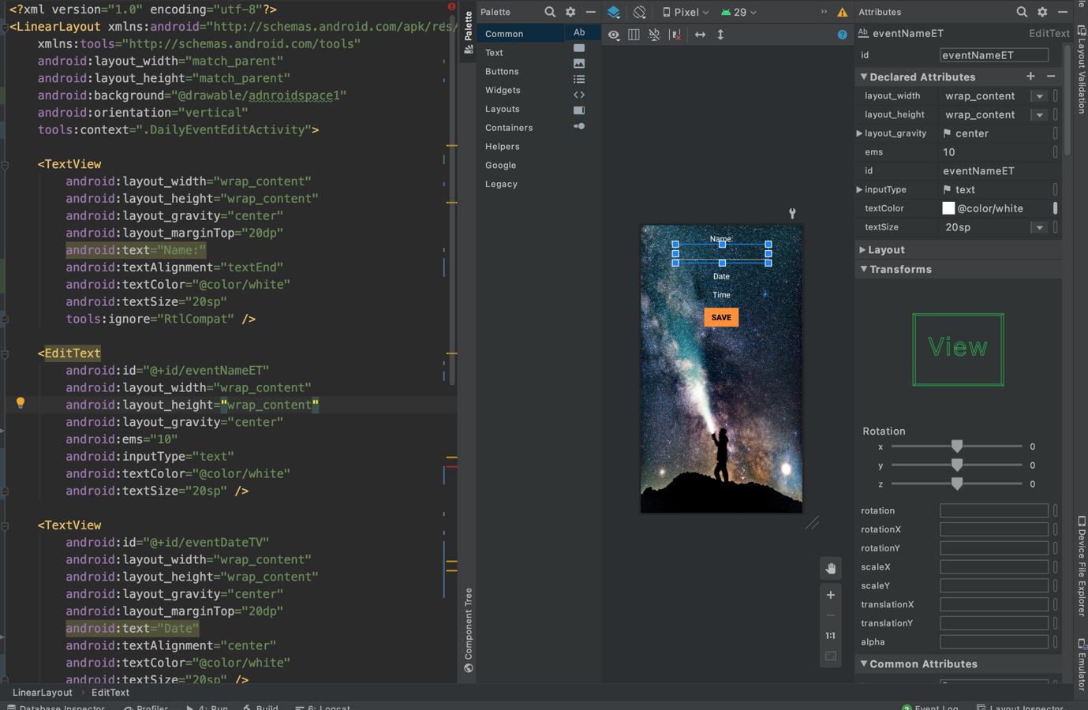

## 8

Week view activity

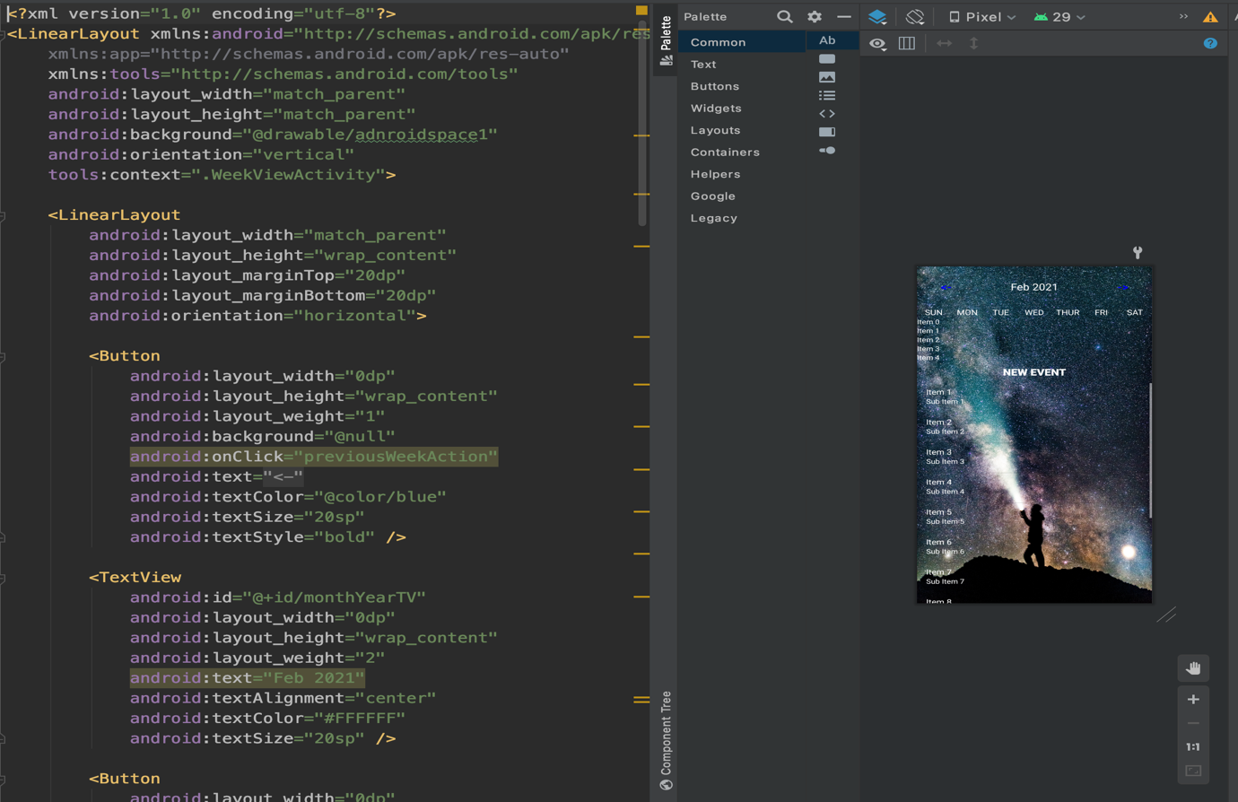

## 9

Cell text for day

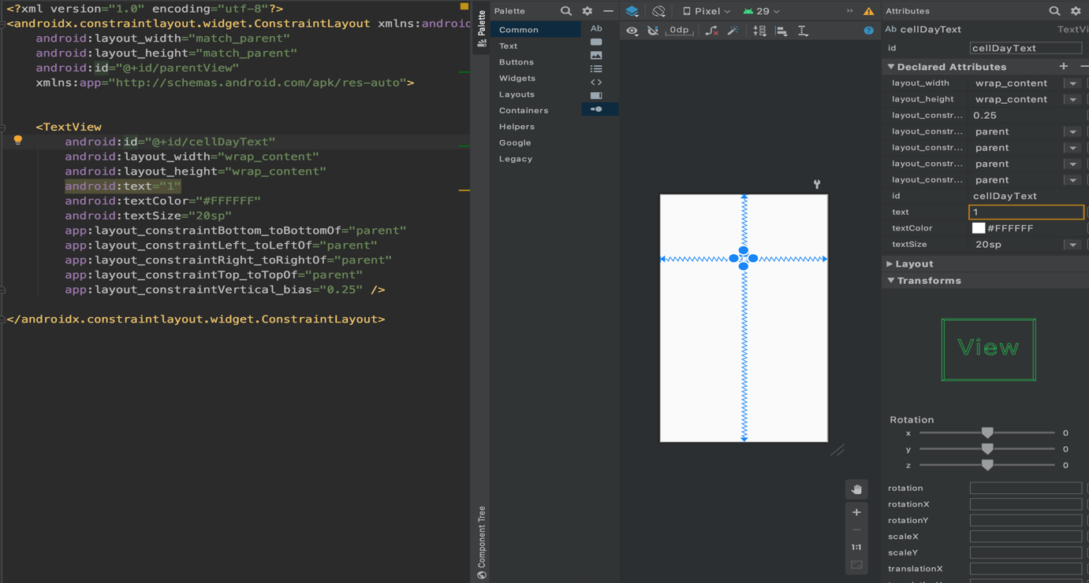

## 10

Text for event cell

